PCA-SIMS Spectra Analysis Report

**Samples Included: Soil-Miami-1, Soil-Miami-2, Biofilm-Glass, Biofilm-PTFE, Lignin-Quartz-1400ppm (negative ions)**

ToF-SIMS testing date(s): 1/1/2020, 1/19/2020, 1/28/2023

ToF-SIMS operator(s): Zihua Zhu

# 2D PCA scores plots

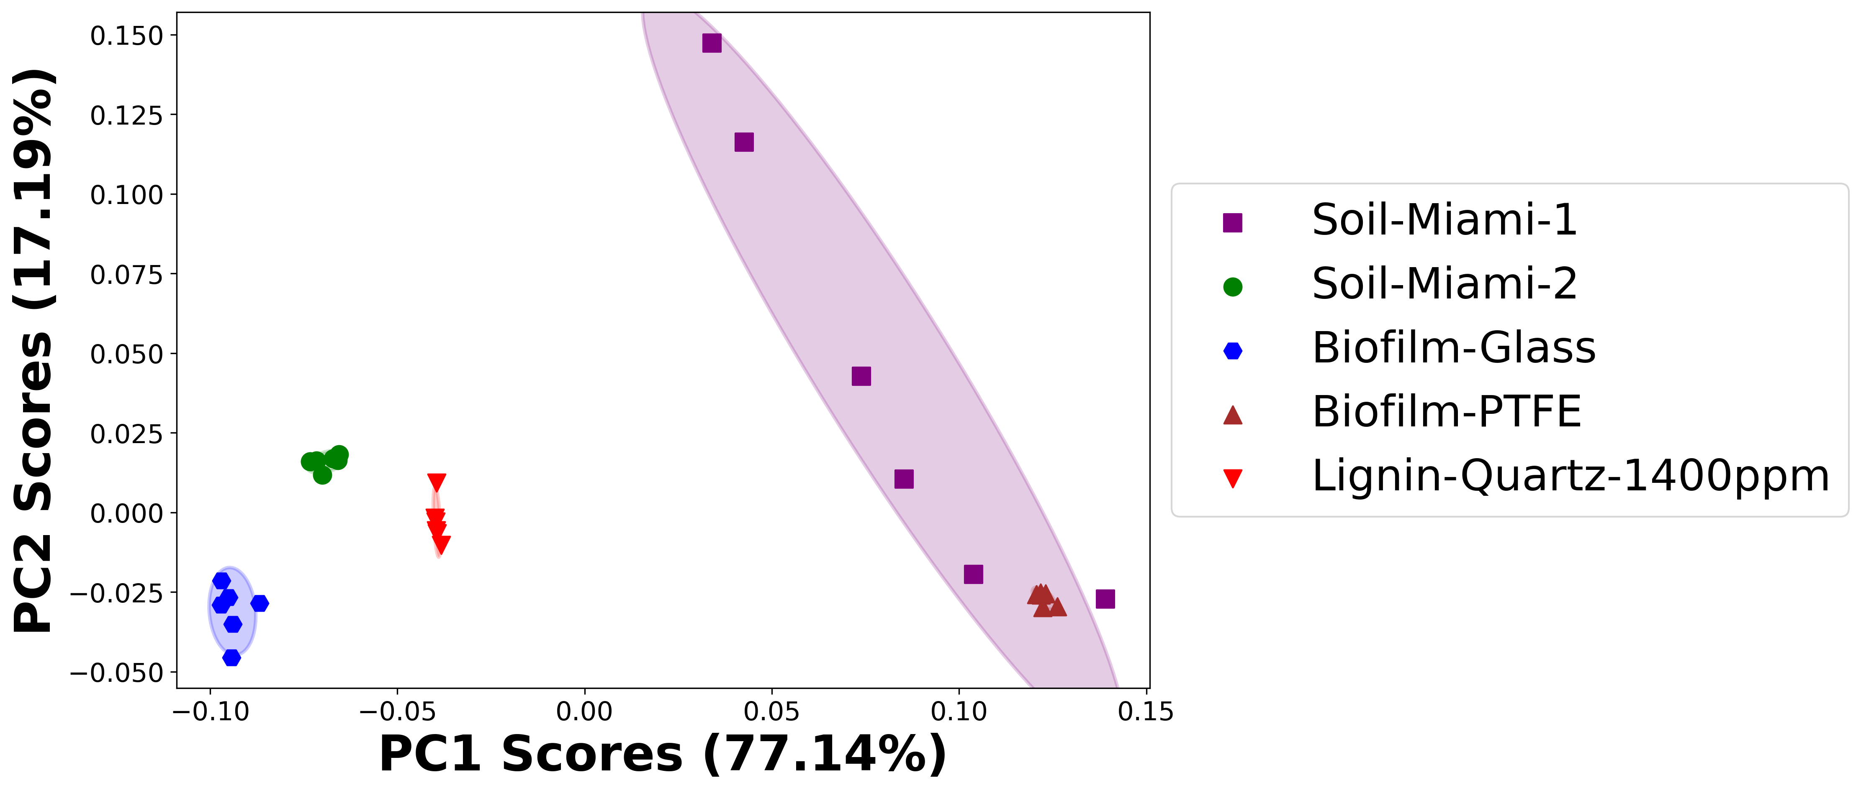

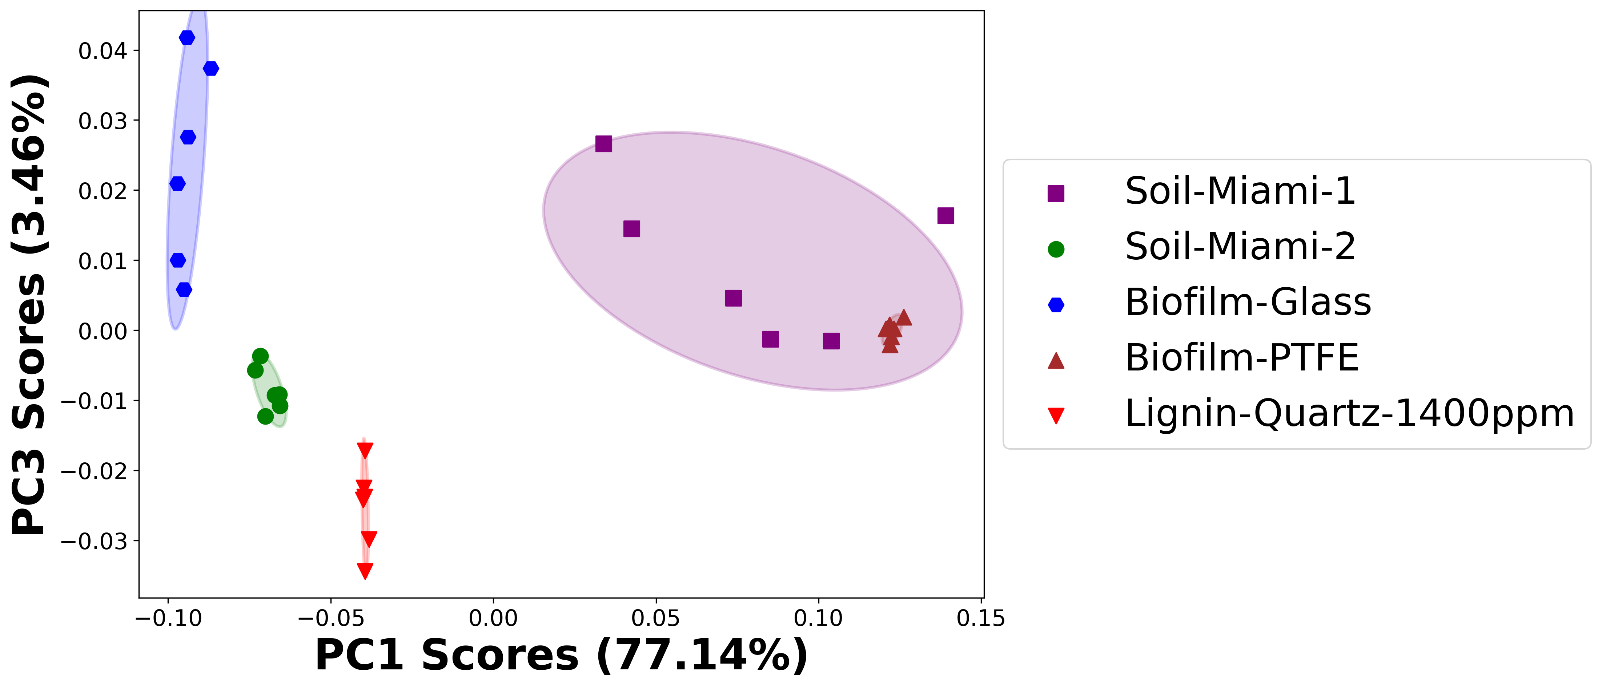

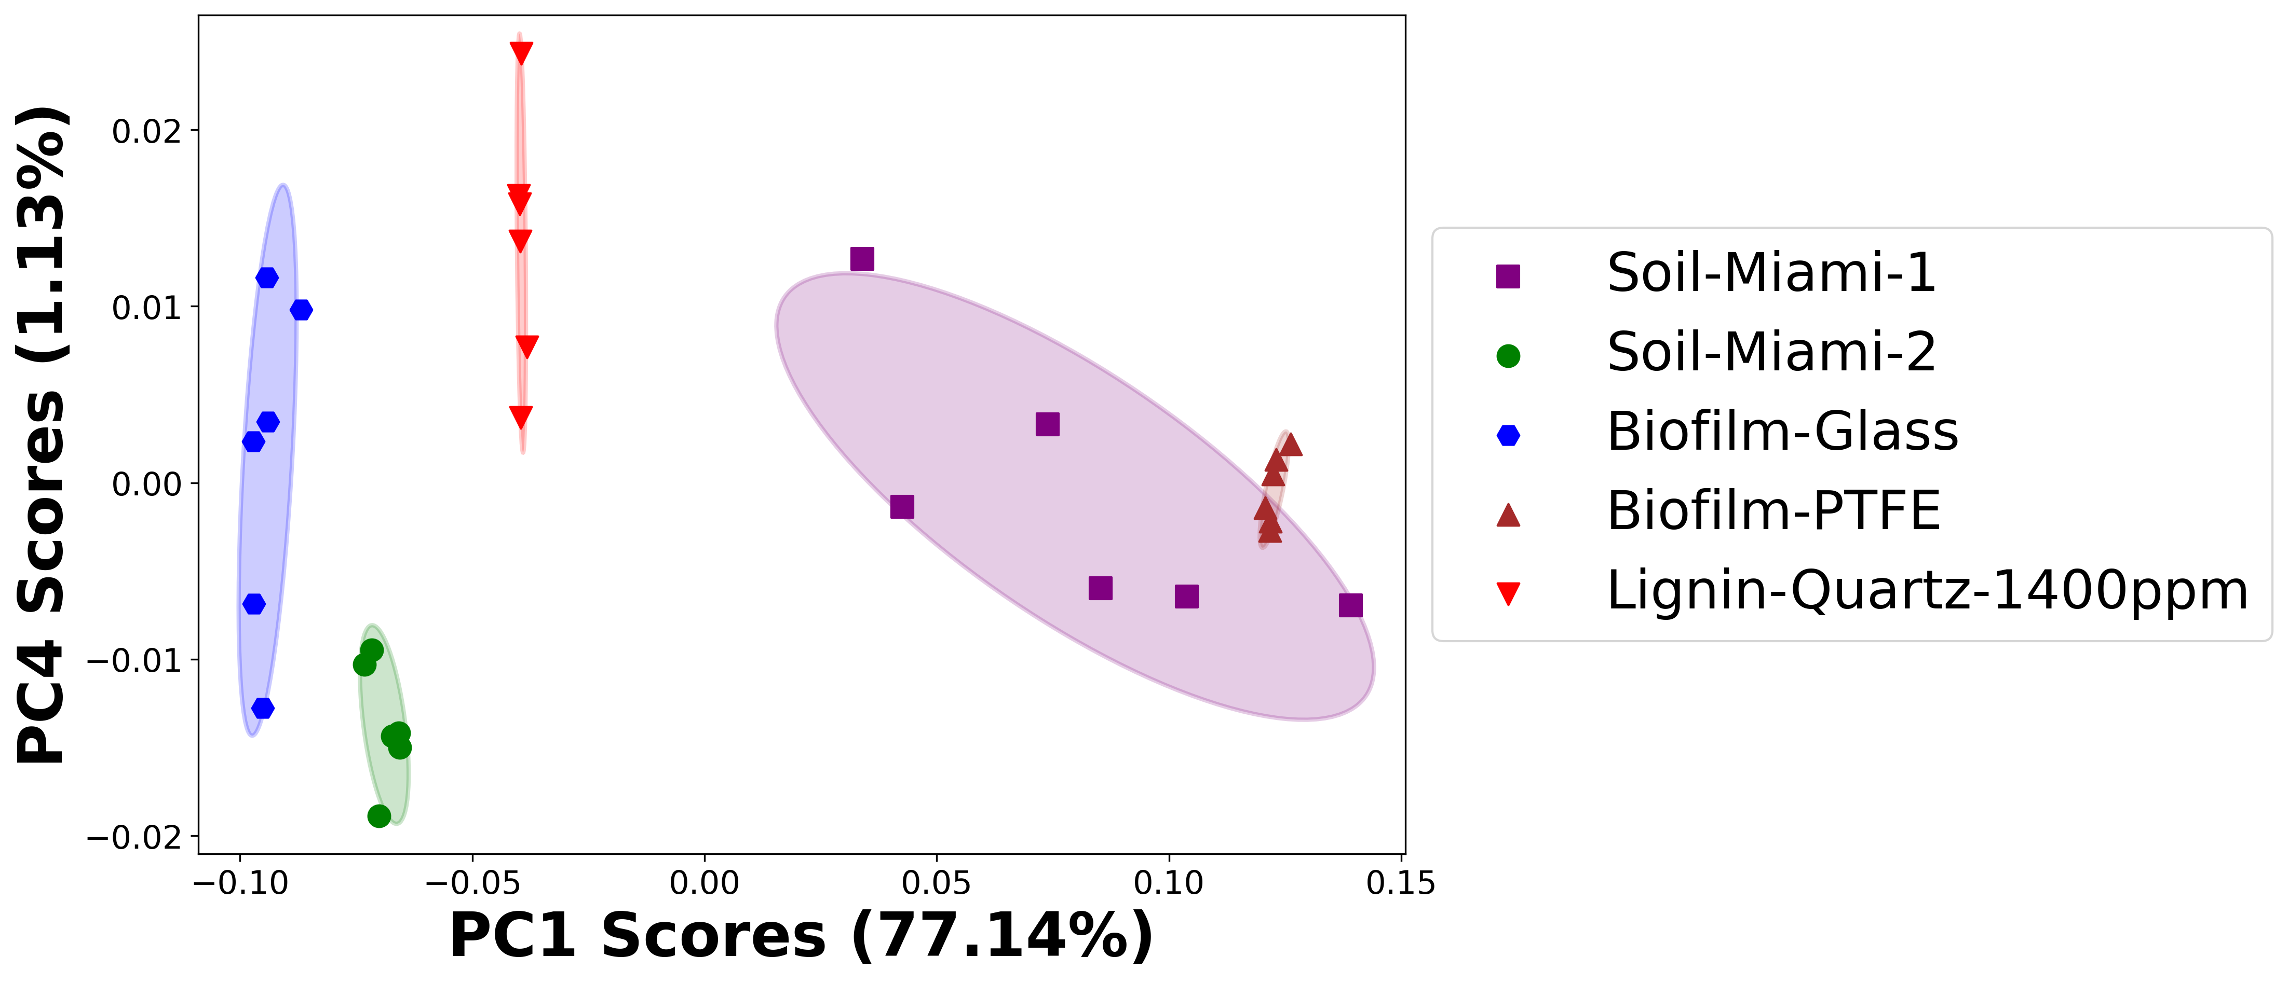

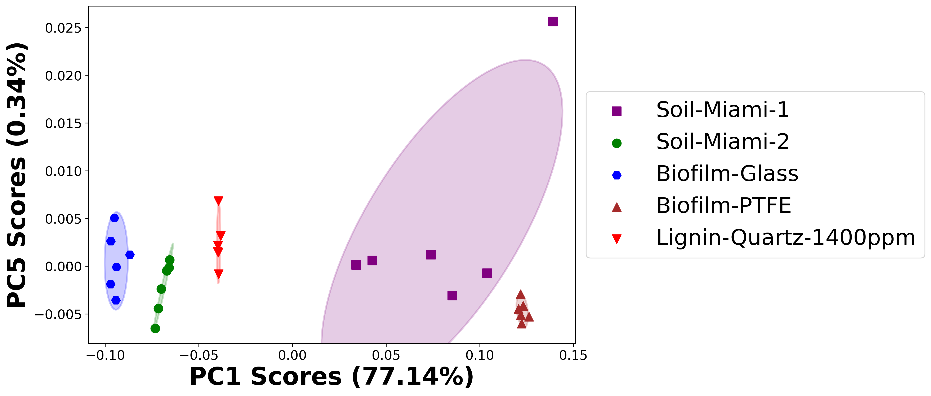

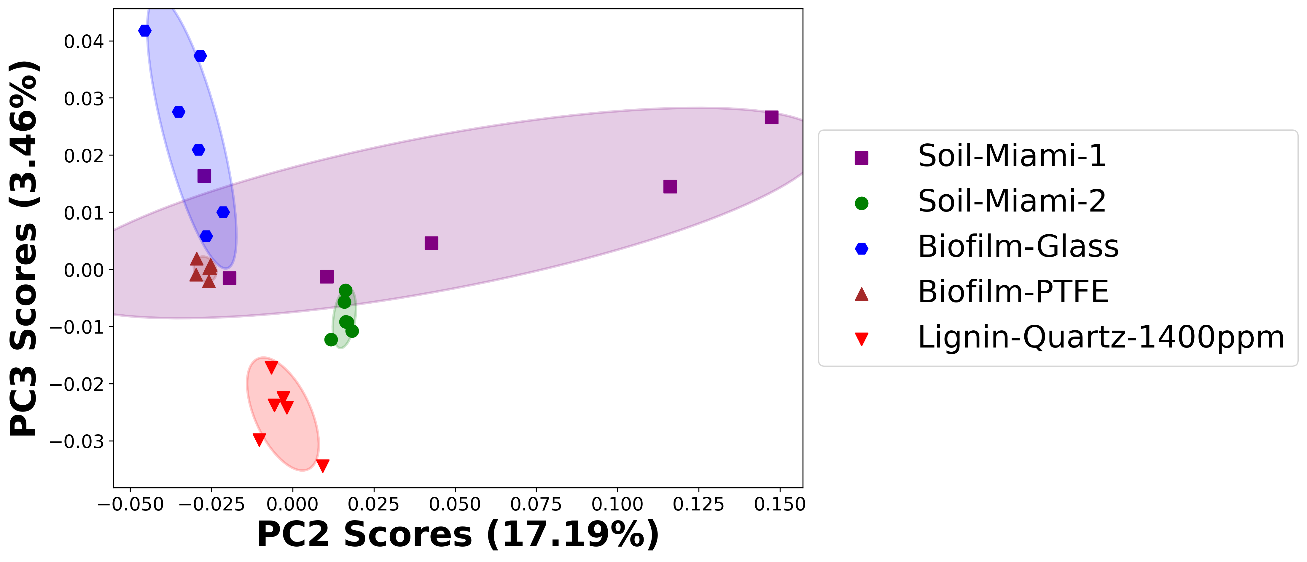

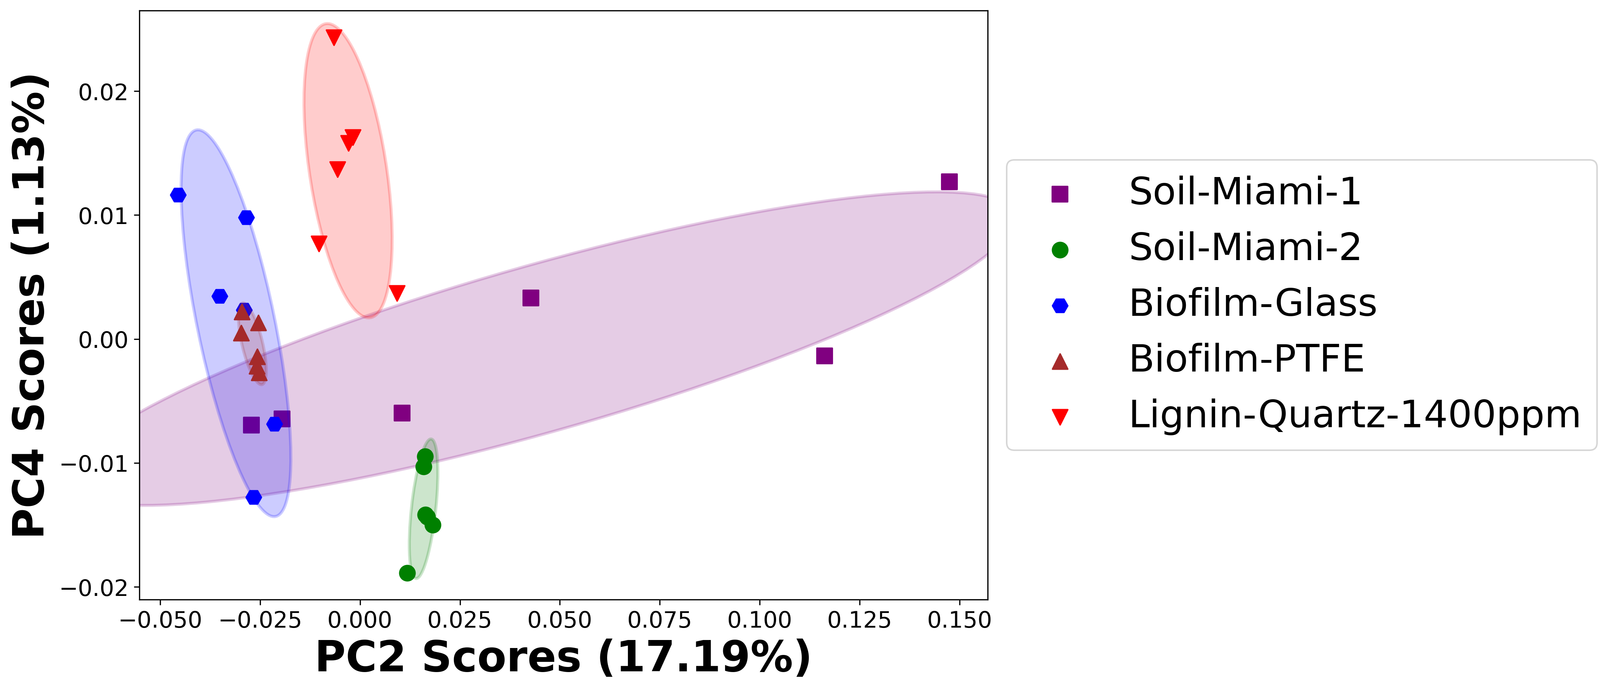

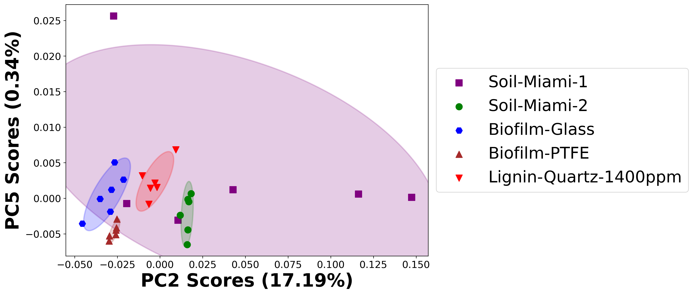

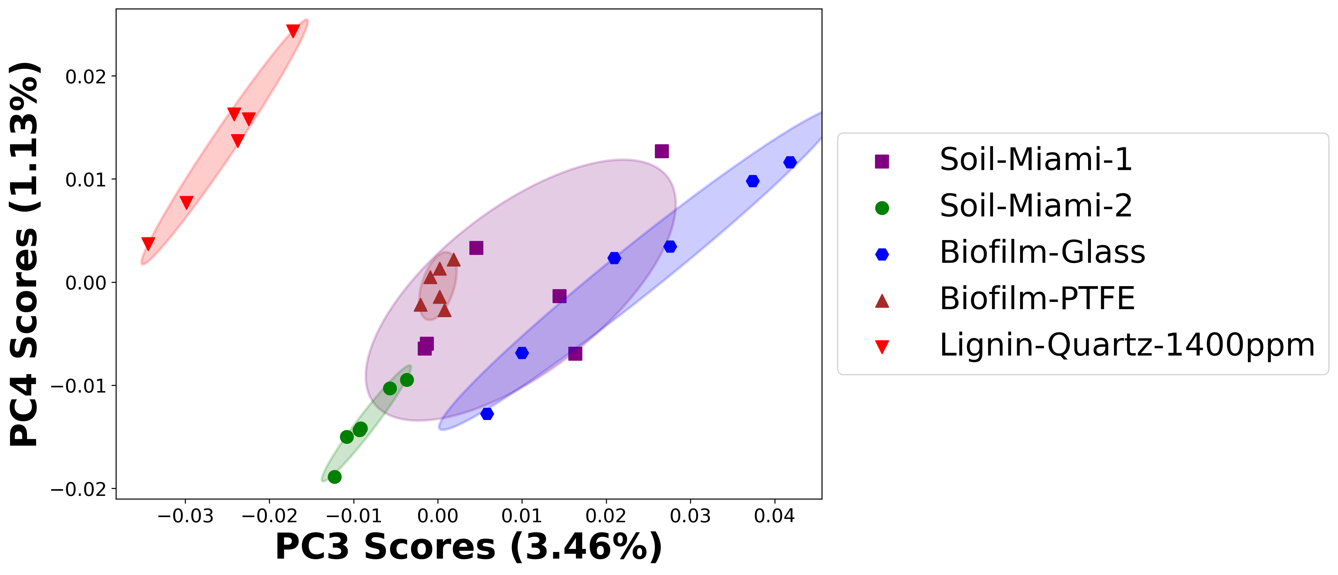

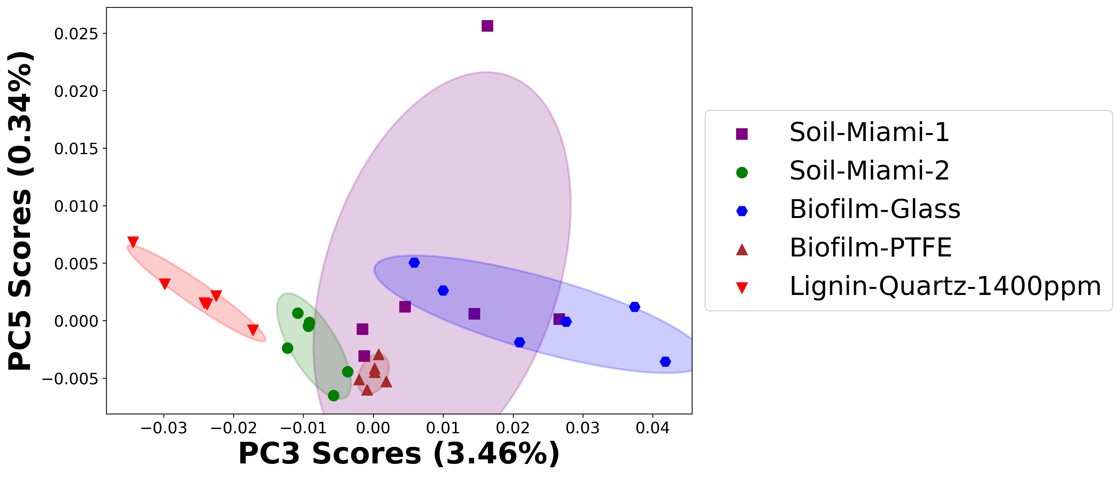

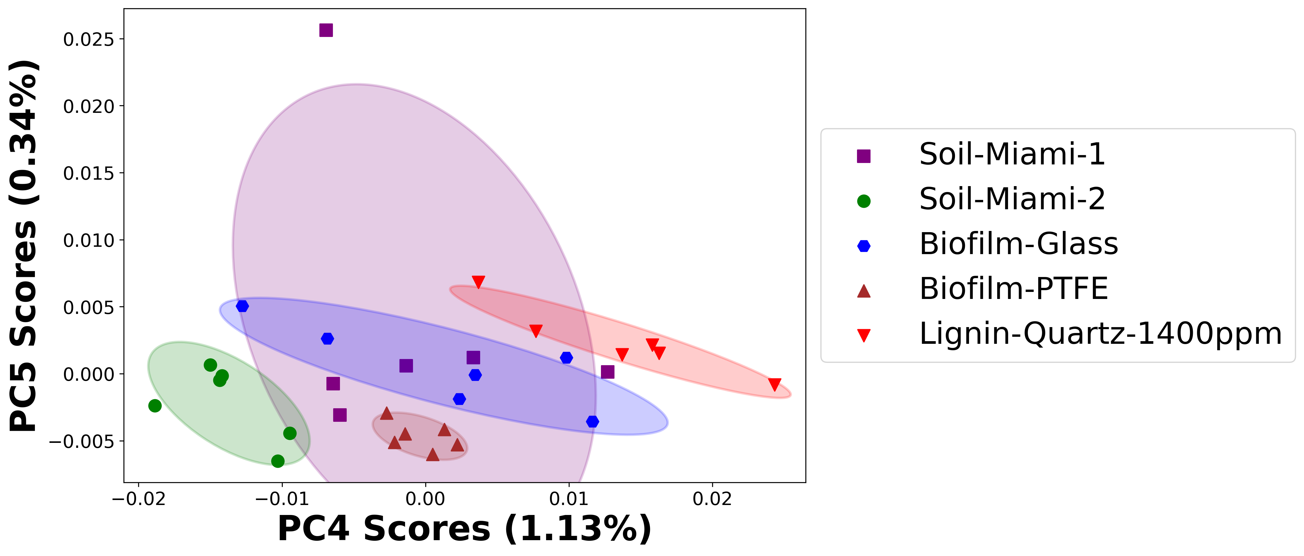

# Negative ion spectra, PCA analysis results -- PC1

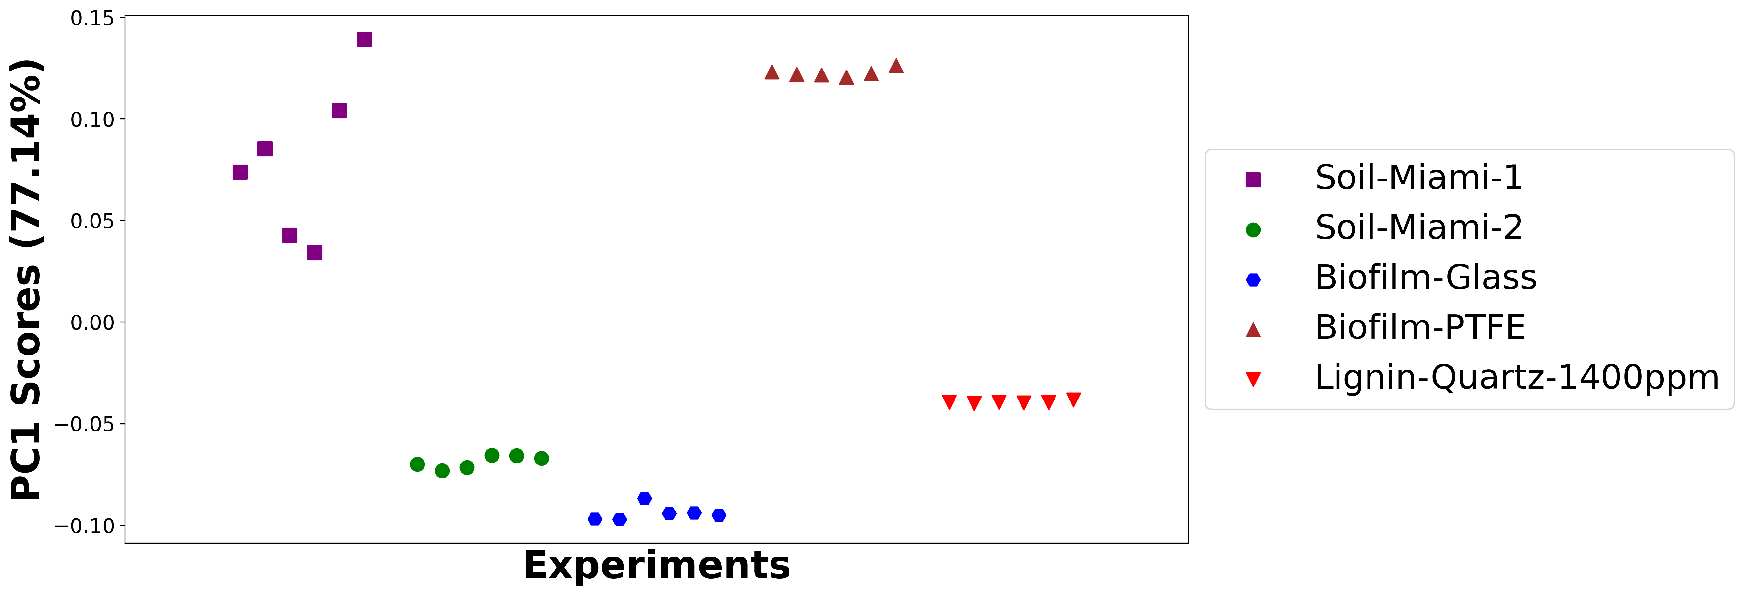

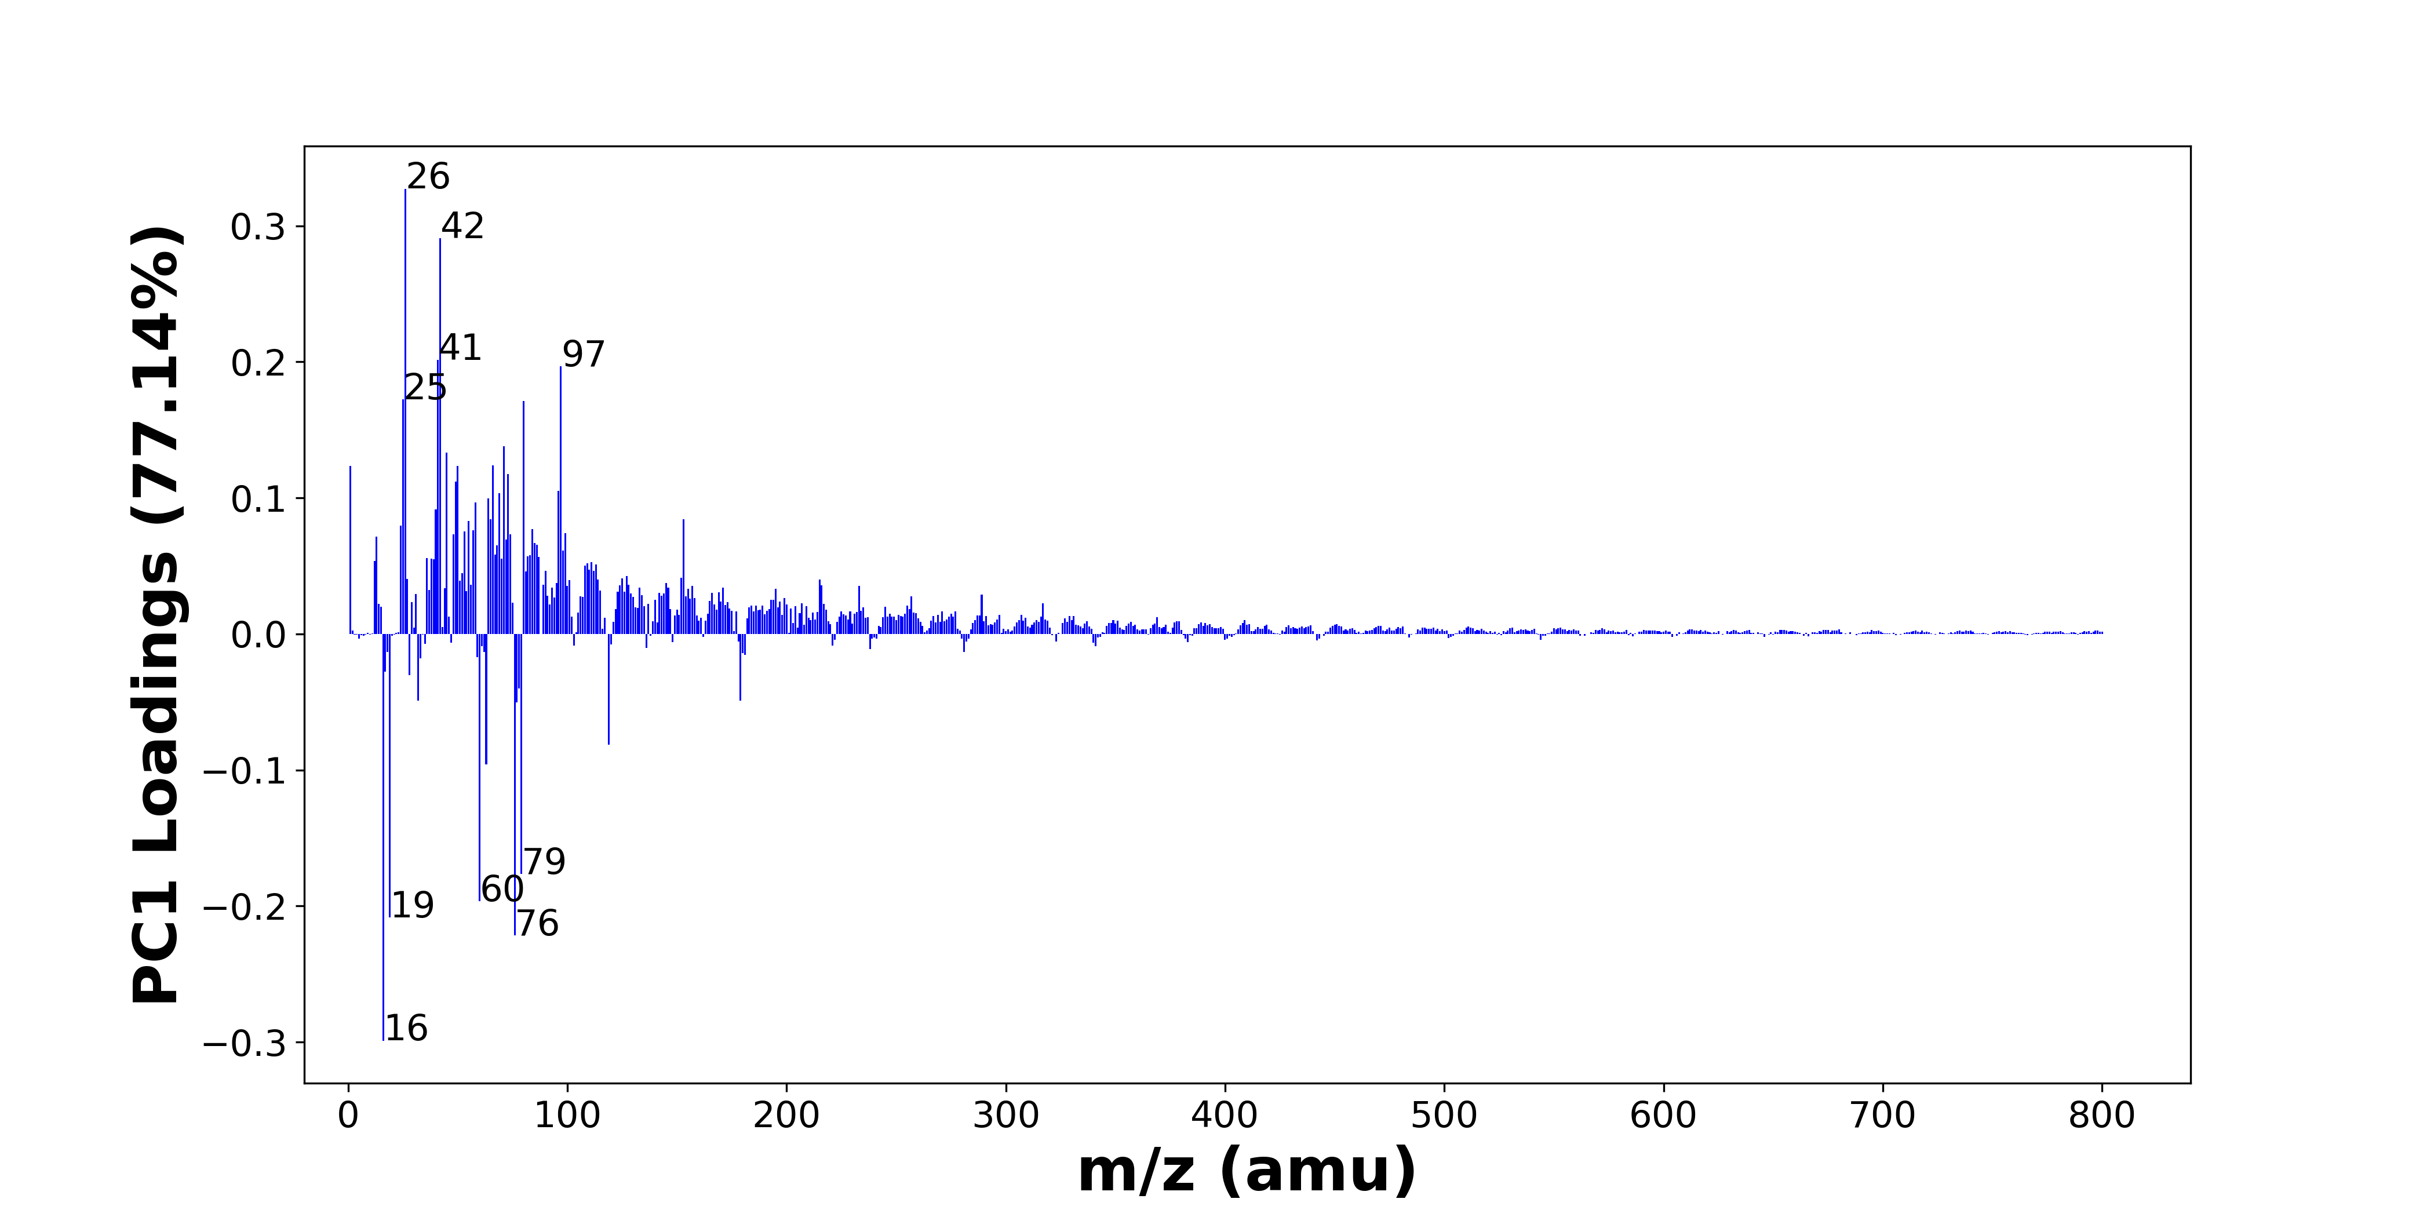

High score samples contain more:

* m/z 26 (CN-), m/z 42 (CNO-), m/z 41 (C2OH-), m/z 97 (H2PO4-, HSO4-), m/z 25 (C2H-), m/z 80 (SO3-), m/z 71 (C3H3O2-), m/z 45 (CO2H-), m/z 66 (C3NO-), m/z 1 (H-), m/z 50 (C3N-), m/z 73 (C6H-), m/z 49 (C4H-), m/z 96 (SO4-), m/z 69 (C3HO2-), m/z 64 (SO2-), m/z 58 (C2H2O2-), m/z 40 (C2O-), m/z 65 (C4OH-), m/z 153 ()
* Nitrogen-containing organics, SOx, Benzene-containing organics, Organic acids

Low score samples contain more:

* m/z 16 (O-), m/z 76 (SiO3-), m/z 19 (F-), m/z 60 (SiO2-), m/z 79 (PO3-), m/z 63 (PO2-), m/z 119 (NaSO4-), m/z 77 (SiO3H-), m/z 32 (O2-, S-), m/z 179 (Si4H3O4-, SiO2NaSO4-), m/z 78 (SNO2-), m/z 28 (Si-), m/z 17 (OH-), m/z 33 (O2H-, SH-), m/z 59 (AlO2-, C2H3O2-), m/z 181 (HSi3O6-), m/z 180 (Si3O6-), m/z 18 (18O-), m/z 281 (C18H33O2-), m/z 62 (30SiO2-, NO3-)
* SiOx, POx

# Negative ion spectra, top positive loadings -- PC1

|  |  |  |  |  |  |  |  |  |
| --- | --- | --- | --- | --- | --- | --- | --- | --- |
| + Loading No. | Unit Mass | Document Mass | Initial Peak Assignment | Initial Probabilities | Measured Mass | Peak Assignment (Qualified) | Updated Peak Assignment (from Document Mass) | Updated Document Mass |
| 1 | 26 | 26.0036 | CN- | 1.0 | 26.0054 | CN- |  |  |
| 2 | 42 | 41.9985 | CNO- | 1.0 | 42.0039 | CNO- |  |  |
| 3 | 41 | 41.0032 | C2OH- | 1.0 | 40.9999 | C2OH- |  |  |
| 4 | 97 | 96.9696 96.9601 | H2PO4- HSO4- | 0.51 0.49 | 96.9643 | H2PO4- HSO4- |  |  |
| 5 | 25 | 25.0083 | C2H- | 1.0 | 25.0087 | C2H- |  |  |
| 6 | 80 | 79.9573 | SO3- | 1.0 | 79.9593 | SO3- |  |  |
| 7 | 71 | 71.0139 | C3H3O2- | 1.0 | 71.0166 | C3H3O2- |  |  |
| 8 | 45 | 44.9982 | CO2H- | 1.0 | 44.9987 | CO2H- |  |  |
| 9 | 66 | 65.9985 | C3NO- | 1.0 | 66.0027 | C3NO- |  |  |
| 10 | 1 | 1.0084 | H- | 1.0 | 1.0085 | H- |  |  |
| 11 | 50 | 50.0036 | C3N- | 1.0 | 50.0057 | C3N- |  |  |
| 12 | 73 | 73.0083 | C6H- | 1.0 |  |  |  |  |
| 13 | 49 | 49.0083 | C4H- | 1.0 |  |  |  |  |
| 14 | 96 | 95.9522 | SO4- | 1.0 |  |  |  |  |
| 15 | 69 | 68.9982 | C3HO2- | 1.0 |  |  |  |  |
| 16 | 64 | 63.9624 | SO2- | 1.0 |  |  |  |  |
| 17 | 58 | 58.006 | C2H2O2- | 1.0 |  |  |  |  |
| 18 | 40 | 39.9954 | C2O- | 1.0 |  |  |  |  |
| 19 | 65 | 65.0032 | C4OH- | 1.0 |  |  |  |  |
| 20 | 153 |  |  |  |  |  |  |  |

Note: Highlighting of the qualified peak assignments represents the error in the document masses relative to the measured mass(es) in that row. Green signifies an error < 100ppm, yellow an error from 100 to 200ppm, and red an error > 200ppm.

# Negative ion spectra, top negative loadings -- PC1

|  |  |  |  |  |  |  |  |  |
| --- | --- | --- | --- | --- | --- | --- | --- | --- |
| - Loading No. | Unit Mass | Document Mass | Initial Peak Assignment | Initial Probabilities | Measured Mass | Peak Assignment (Qualified) | Updated Peak Assignment (from Document Mass) | Updated Document Mass |
| 1 | 16 | 15.9955 | O- | 1.0 | 15.9974 | O- |  |  |
| 2 | 76 | 75.9622 | SiO3- | 1.0 | 75.9663 | SiO3- |  |  |
| 3 | 19 | 18.999 | F- | 1.0 | 18.9991 | F- |  |  |
| 4 | 60 | 59.9673 | SiO2- | 1.0 | 59.9705 | SiO2- |  |  |
| 5 | 79 | 78.959 | PO3- | 1.0 | 78.9674 | PO3- |  |  |
| 6 | 63 | 62.9641 | PO2- | 1.0 | 62.9678 | PO2- |  |  |
| 7 | 119 | 118.942 | NaSO4- | 1.0 | 118.9403 | NaSO4- |  |  |
| 8 | 77 | 76.9741 | SiO3H- | 1.0 | 76.9736 | SiO3H- |  |  |
| 9 | 32 | 31.9903 31.9726 | O2- S- | 0.543 0.457 | 31.9900 | O2- S- |  |  |
| 10 | 179 | 178.9114 178.9088 | Si4H3O4- SiO2NaSO4- | 0.506 0.494 | 178.9184 | Si4H3O4- SiO2NaSO4- |  |  |
| 11 | 78 | 77.9655 | SNO2- | 1.0 | 77.9667 | SNO2- |  |  |
| 12 | 28 | 27.9775 | Si- | 1.0 | 27.9771 | Si- |  |  |
| 13 | 17 | 17.0032 | OH- | 1.0 | 17.0043 | OH- |  |  |
| 14 | 33 | 32.9982 32.9804 | O2H- SH- | 0.541 0.459 |  |  |  |  |
| 15 | 59 | 58.9719 59.0139 | AlO2- C2H3O2- | 0.602 0.398 | 58.9735 59.0157 | AlO2- C2H3O2- |  |  |
| 16 | 181 | 180.9087 | HSi3O6- | 1.0 |  |  |  |  |
| 17 | 180 | 179.9008 | Si3O6- | 1.0 |  |  |  |  |
| 18 | 18 | 17.9997 | 18O- | 1.0 |  |  |  |  |
| 19 | 281 | 281.2486 | C18H33O2- | 1.0 |  |  |  |  |
| 20 | 62 | 61.9641 61.9883 | 30SiO2- NO3- | 0.512 0.488 | 61.9668 61.9887 | 30SiO2- NO3- |  |  |

Note: Highlighting of the qualified peak assignments represents the error in the document masses relative to the measured mass(es) in that row. Green signifies an error < 100ppm, yellow an error from 100 to 200ppm, and red an error > 200ppm.

# Negative ion spectra, molecular information from PC1 loadings plot

* The major positive PC1 loadings are m/z 26 (CN-), m/z 42 (CNO-), m/z 41 (C2OH-), m/z 97 (H2PO4-, HSO4-), m/z 25 (C2H-), m/z 80 (SO3-), m/z 71 (C3H3O2-), m/z 45 (CO2H-), m/z 66 (C3NO-), m/z 1 (H-), m/z 50 (C3N-), m/z 73 (C6H-), m/z 49 (C4H-), m/z 96 (SO4-), m/z 69 (C3HO2-), m/z 64 (SO2-), m/z 58 (C2H2O2-), m/z 40 (C2O-), m/z 65 (C4OH-), m/z 153 (), indicating they are more observed in high PC1 score samples.
* The major negative PC1 loadings are m/z 16 (O-), m/z 76 (SiO3-), m/z 19 (F-), m/z 60 (SiO2-), m/z 79 (PO3-), m/z 63 (PO2-), m/z 119 (NaSO4-), m/z 77 (SiO3H-), m/z 32 (O2-, S-), m/z 179 (Si4H3O4-, SiO2NaSO4-), m/z 78 (SNO2-), m/z 28 (Si-), m/z 17 (OH-), m/z 33 (O2H-, SH-), m/z 59 (AlO2-, C2H3O2-), m/z 181 (HSi3O6-), m/z 180 (Si3O6-), m/z 18 (18O-), m/z 281 (C18H33O2-), m/z 62 (30SiO2-, NO3-), indicating they are more observed in low PC1 score samples.
* Nitrogen-containing organics signals, such as m/z 26 (CN-), m/z 42 (CNO-), are mostly found in positive loadings, indicating that high PC1 score samples contain more Nitrogen-containing organics.
* SOx signals, such as m/z 64 (SO2-), m/z 80 (SO3-), m/z 96 (SO4-), are mostly found in positive loadings, indicating that high PC1 score samples contain more SOx.
* Benzene-containing organics signals, such as m/z 49 (C4H-), m/z 73 (C6H-), are mostly found in positive loadings, indicating that high PC1 score samples contain more Benzene-containing organics.
* Organic acids signals, such as m/z 45 (CO2H-), are mostly found in positive loadings, indicating that high PC1 score samples contain more Organic acids.
* SiOx signals, such as m/z 60 (SiO2-), m/z 76 (SiO3-), m/z 77 (SiO3H-), are mostly found in negative loadings, indicating that low PC1 score samples contain more SiOx.
* POx signals, such as m/z 63 (PO2-), m/z 79 (PO3-), are mostly found in negative loadings, indicating that low PC1 score samples contain more POx.

# Negative ion spectra, PCA analysis results -- PC2

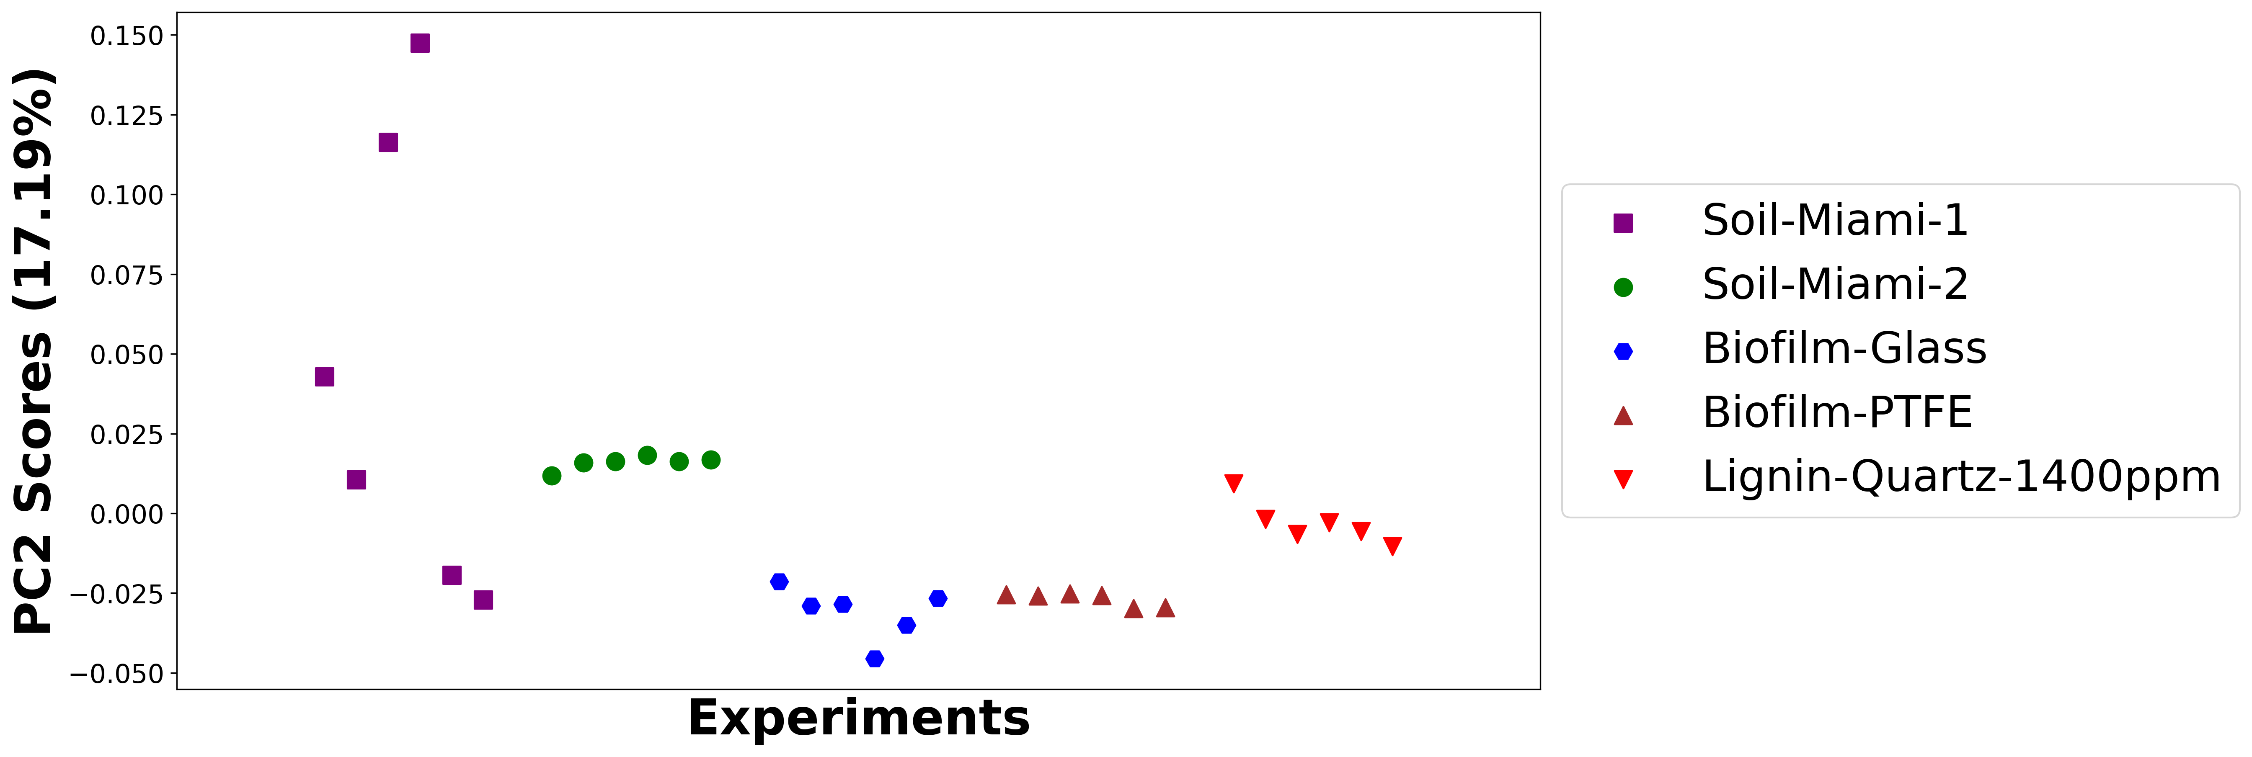

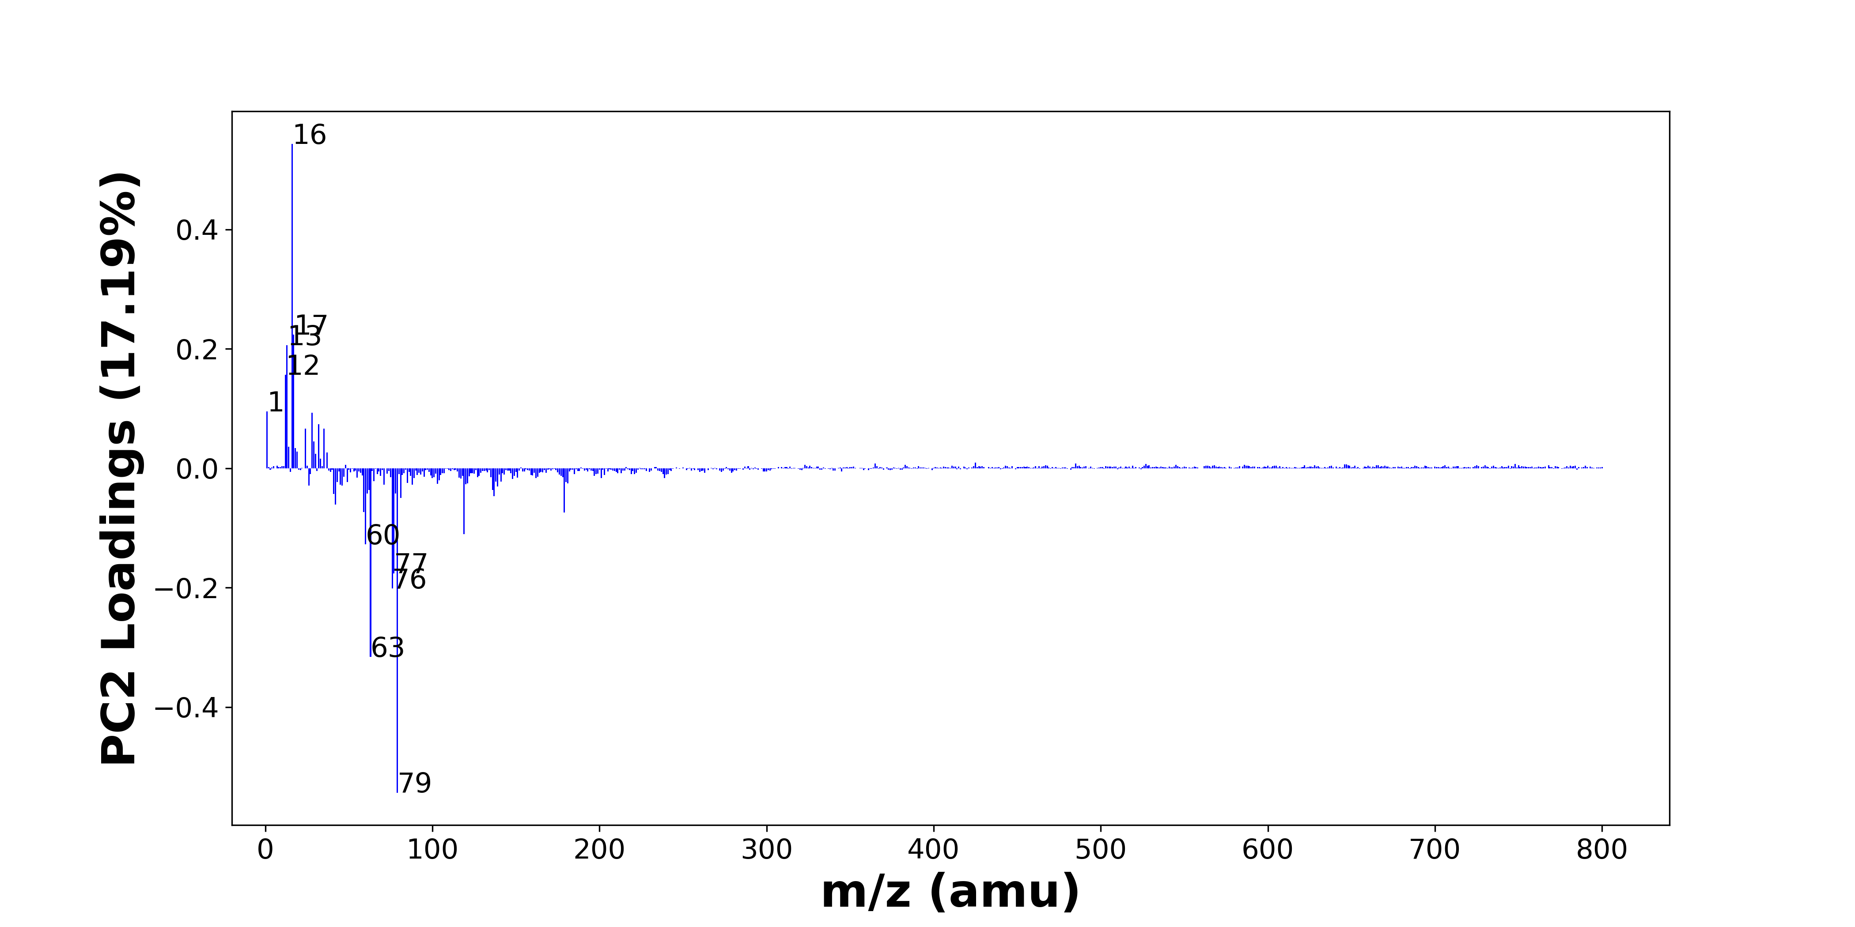

High score samples contain more:

* m/z 16 (O-), m/z 17 (OH-), m/z 13 (CH-), m/z 12 (C-), m/z 1 (H-), m/z 28 (Si-), m/z 32 (O2-, S-), m/z 24 (C2-), m/z 35 (Cl-), m/z 29 (SiH-, CHO-), m/z 14 (), m/z 18 (18O-), m/z 19 (F-), m/z 37 (37Cl-, C3H-), m/z 30 (), m/z 33 (O2H-, SH-), m/z 425 (), m/z 485 (), m/z 365 (), m/z 748 ()
* Hydrocarbons

Low score samples contain more:

* m/z 79 (PO3-), m/z 63 (PO2-), m/z 76 (SiO3-), m/z 77 (SiO3H-), m/z 60 (SiO2-), m/z 119 (NaSO4-), m/z 179 (Si4H3O4-, SiO2NaSO4-), m/z 59 (AlO2-, C2H3O2-), m/z 42 (CNO-), m/z 81 (), m/z 137 (Si2O5H-), m/z 41 (C2OH-), m/z 61 (SiO2H-), m/z 78 (SNO2-), m/z 136 (Si2O5-), m/z 62 (30SiO2-, NO3-), m/z 139 (), m/z 26 (CN-), m/z 46 (NO2-), m/z 45 (CO2H-)
* Nitrogen-containing organics, SiOx, POx, NOx, Organic acids

# Negative ion spectra, top positive loadings -- PC2

|  |  |  |  |  |  |  |  |  |
| --- | --- | --- | --- | --- | --- | --- | --- | --- |
| + Loading No. | Unit Mass | Document Mass | Initial Peak Assignment | Initial Probabilities | Measured Mass | Peak Assignment (Qualified) | Updated Peak Assignment (from Document Mass) | Updated Document Mass |
| 1 | 16 | 15.9955 | O- | 1.0 | 15.9974 | O- |  |  |
| 2 | 17 | 17.0032 | OH- | 1.0 | 17.0043 | OH- |  |  |
| 3 | 13 | 13.0084 | CH- | 1.0 | 13.0084 | CH- |  |  |
| 4 | 12 | 12.0005 | C- | 1.0 | 12.0065 | C- |  |  |
| 5 | 1 | 1.0084 | H- | 1.0 | 1.0085 | H- |  |  |
| 6 | 28 | 27.9775 | Si- | 1.0 | 27.9771 | Si- |  |  |
| 7 | 32 | 31.9903 31.9726 | O2- S- | 0.543 0.457 | 31.9900 | O2- S- |  |  |
| 8 | 24 | 24.0005 | C2- | 1.0 | 24.0003 | C2- |  |  |
| 9 | 35 | 34.9694 | Cl- | 1.0 | 34.9695 | Cl- |  |  |
| 10 | 29 | 28.9853 29.0028 | SiH- CHO- | 0.54 0.46 |  |  |  |  |
| 11 | 14 |  |  |  |  |  |  |  |
| 12 | 18 | 17.9997 | 18O- | 1.0 |  |  |  |  |
| 13 | 19 | 18.999 | F- | 1.0 | 18.9991 | F- |  |  |
| 14 | 37 | 36.9664 37.0084 | 37Cl- C3H- | 0.584 0.416 | 36.9670 37.0091 | 37Cl- C3H- |  |  |
| 15 | 30 |  |  |  |  |  |  |  |
| 16 | 33 | 32.9982 32.9804 | O2H- SH- | 0.541 0.459 |  |  |  |  |
| 17 | 425 |  |  |  |  |  |  |  |
| 18 | 485 |  |  |  |  |  |  |  |
| 19 | 365 |  |  |  |  |  |  |  |
| 20 | 748 |  |  |  |  |  |  |  |

Note: Highlighting of the qualified peak assignments represents the error in the document masses relative to the measured mass(es) in that row. Green signifies an error < 100ppm, yellow an error from 100 to 200ppm, and red an error > 200ppm.

# Negative ion spectra, top negative loadings -- PC2

|  |  |  |  |  |  |  |  |  |
| --- | --- | --- | --- | --- | --- | --- | --- | --- |
| - Loading No. | Unit Mass | Document Mass | Initial Peak Assignment | Initial Probabilities | Measured Mass | Peak Assignment (Qualified) | Updated Peak Assignment (from Document Mass) | Updated Document Mass |
| 1 | 79 | 78.959 | PO3- | 1.0 | 78.9674 | PO3- |  |  |
| 2 | 63 | 62.9641 | PO2- | 1.0 | 62.9678 | PO2- |  |  |
| 3 | 76 | 75.9622 | SiO3- | 1.0 | 75.9663 | SiO3- |  |  |
| 4 | 77 | 76.9741 | SiO3H- | 1.0 | 76.9736 | SiO3H- |  |  |
| 5 | 60 | 59.9673 | SiO2- | 1.0 | 59.9705 | SiO2- |  |  |
| 6 | 119 | 118.942 | NaSO4- | 1.0 | 118.9403 | NaSO4- |  |  |
| 7 | 179 | 178.9114 178.9088 | Si4H3O4- SiO2NaSO4- | 0.506 0.494 | 178.9184 | Si4H3O4- SiO2NaSO4- |  |  |
| 8 | 59 | 58.9719 59.0139 | AlO2- C2H3O2- | 0.602 0.398 | 58.9735 59.0157 | AlO2- C2H3O2- |  |  |
| 9 | 42 | 41.9985 | CNO- | 1.0 | 42.0039 | CNO- |  |  |
| 10 | 81 |  |  |  |  |  |  |  |
| 11 | 137 | 136.9368 | Si2O5H- | 1.0 | 136.9413 | Si2O5H- |  |  |
| 12 | 41 | 41.0032 | C2OH- | 1.0 | 40.9999 | C2OH- |  |  |
| 13 | 61 | 60.9751 | SiO2H- | 1.0 | 60.9751 | SiO2H- |  |  |
| 14 | 78 | 77.9655 | SNO2- | 1.0 | 77.9667 | SNO2- |  |  |
| 15 | 136 | 135.9289 | Si2O5- | 1.0 |  |  |  |  |
| 16 | 62 | 61.9641 61.9883 | 30SiO2- NO3- | 0.512 0.488 | 61.9668 61.9887 | 30SiO2- NO3- |  |  |
| 17 | 139 |  |  |  |  |  |  |  |
| 18 | 26 | 26.0036 | CN- | 1.0 | 26.0054 | CN- |  |  |
| 19 | 46 | 45.9934 | NO2- | 1.0 |  |  |  |  |
| 20 | 45 | 44.9982 | CO2H- | 1.0 | 44.9987 | CO2H- |  |  |

Note: Highlighting of the qualified peak assignments represents the error in the document masses relative to the measured mass(es) in that row. Green signifies an error < 100ppm, yellow an error from 100 to 200ppm, and red an error > 200ppm.

# Negative ion spectra, molecular information from PC2 loadings plot

* The major positive PC2 loadings are m/z 16 (O-), m/z 17 (OH-), m/z 13 (CH-), m/z 12 (C-), m/z 1 (H-), m/z 28 (Si-), m/z 32 (O2-, S-), m/z 24 (C2-), m/z 35 (Cl-), m/z 29 (SiH-, CHO-), m/z 14 (), m/z 18 (18O-), m/z 19 (F-), m/z 37 (37Cl-, C3H-), m/z 30 (), m/z 33 (O2H-, SH-), m/z 425 (), m/z 485 (), m/z 365 (), m/z 748 (), indicating they are more observed in high PC2 score samples.
* The major negative PC2 loadings are m/z 79 (PO3-), m/z 63 (PO2-), m/z 76 (SiO3-), m/z 77 (SiO3H-), m/z 60 (SiO2-), m/z 119 (NaSO4-), m/z 179 (Si4H3O4-, SiO2NaSO4-), m/z 59 (AlO2-, C2H3O2-), m/z 42 (CNO-), m/z 81 (), m/z 137 (Si2O5H-), m/z 41 (C2OH-), m/z 61 (SiO2H-), m/z 78 (SNO2-), m/z 136 (Si2O5-), m/z 62 (30SiO2-, NO3-), m/z 139 (), m/z 26 (CN-), m/z 46 (NO2-), m/z 45 (CO2H-), indicating they are more observed in low PC2 score samples.
* Hydrocarbons signals, such as m/z 12 (C-), m/z 13 (CH-), m/z 24 (C2-), are mostly found in positive loadings, indicating that high PC2 score samples contain more Hydrocarbons.
* Nitrogen-containing organics signals, such as m/z 26 (CN-), m/z 42 (CNO-), are mostly found in negative loadings, indicating that low PC2 score samples contain more Nitrogen-containing organics.
* SiOx signals, such as m/z 60 (SiO2-), m/z 61 (SiO2H-), m/z 76 (SiO3-), m/z 77 (SiO3H-), m/z 136 (Si2O5-), m/z 137 (Si2O5H-), are mostly found in negative loadings, indicating that low PC2 score samples contain more SiOx.
* POx signals, such as m/z 63 (PO2-), m/z 79 (PO3-), are mostly found in negative loadings, indicating that low PC2 score samples contain more POx.
* NOx signals, such as m/z 46 (NO2-), m/z 62 (30SiO2-, NO3-), are mostly found in negative loadings, indicating that low PC2 score samples contain more NOx.
* Organic acids signals, such as m/z 45 (CO2H-), are mostly found in negative loadings, indicating that low PC2 score samples contain more Organic acids.

# Negative ion spectra, PCA analysis results -- PC3

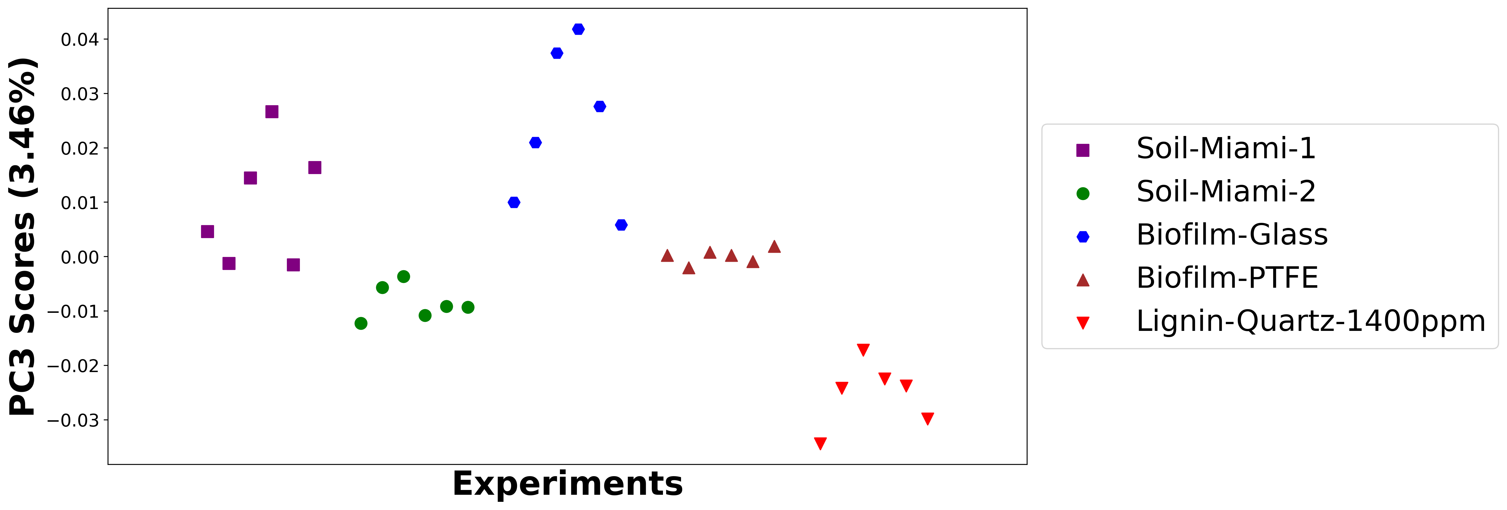

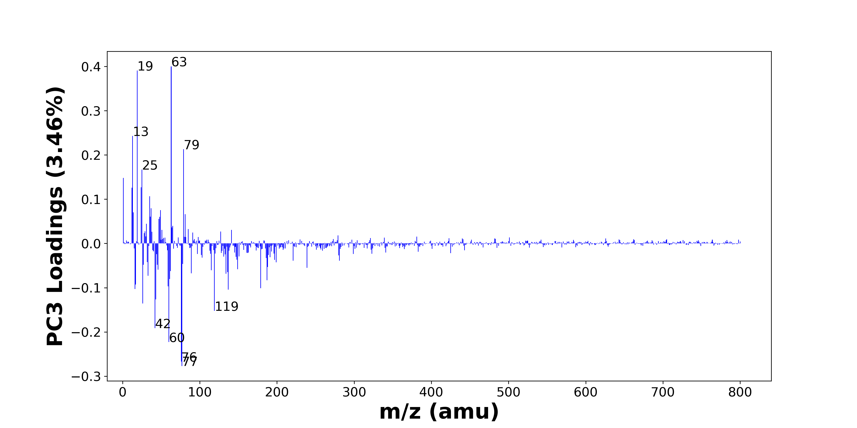

High score samples contain more:

* m/z 63 (PO2-), m/z 19 (F-), m/z 13 (CH-), m/z 79 (PO3-), m/z 25 (C2H-), m/z 1 (H-), m/z 24 (C2-), m/z 12 (C-), m/z 35 (Cl-), m/z 37 (37Cl-, C3H-), m/z 49 (C4H-), m/z 14 (), m/z 81 (), m/z 36 (C3-), m/z 48 (C4-), m/z 47 (PO-), m/z 31 (), m/z 65 (C4OH-), m/z 64 (SO2-), m/z 85 ()
* Hydrocarbons, SOx, POx, Benzene-containing organics

Low score samples contain more:

* m/z 77 (SiO3H-), m/z 76 (SiO3-), m/z 60 (SiO2-), m/z 42 (CNO-), m/z 119 (NaSO4-), m/z 26 (CN-), m/z 43 (BO2-, AlO-, CHNO-, C2H3O-), m/z 137 (Si2O5H-), m/z 16 (O-), m/z 179 (Si4H3O4-, SiO2NaSO4-), m/z 59 (AlO2-, C2H3O2-), m/z 17 (OH-), m/z 187 (), m/z 61 (SiO2H-), m/z 33 (O2H-, SH-), m/z 134 (), m/z 89 (), m/z 136 (Si2O5-), m/z 62 (30SiO2-, NO3-), m/z 115 ()
* Nitrogen-containing organics, SiOx, NOx

# Negative ion spectra, top positive loadings -- PC3

|  |  |  |  |  |  |  |  |  |
| --- | --- | --- | --- | --- | --- | --- | --- | --- |
| + Loading No. | Unit Mass | Document Mass | Initial Peak Assignment | Initial Probabilities | Measured Mass | Peak Assignment (Qualified) | Updated Peak Assignment (from Document Mass) | Updated Document Mass |
| 1 | 63 | 62.9641 | PO2- | 1.0 | 62.9678 | PO2- |  |  |
| 2 | 19 | 18.999 | F- | 1.0 | 18.9991 | F- |  |  |
| 3 | 13 | 13.0084 | CH- | 1.0 | 13.0084 | CH- |  |  |
| 4 | 79 | 78.959 | PO3- | 1.0 | 78.9674 | PO3- |  |  |
| 5 | 25 | 25.0083 | C2H- | 1.0 | 25.0087 | C2H- |  |  |
| 6 | 1 | 1.0084 | H- | 1.0 | 1.0085 | H- |  |  |
| 7 | 24 | 24.0005 | C2- | 1.0 | 24.0003 | C2- |  |  |
| 8 | 12 | 12.0005 | C- | 1.0 | 12.0065 | C- |  |  |
| 9 | 35 | 34.9694 | Cl- | 1.0 | 34.9695 | Cl- |  |  |
| 10 | 37 | 36.9664 37.0084 | 37Cl- C3H- | 0.584 0.416 | 36.9670 37.0091 | 37Cl- C3H- |  |  |
| 11 | 49 | 49.0083 | C4H- | 1.0 |  |  |  |  |
| 12 | 14 |  |  |  |  |  |  |  |
| 13 | 81 |  |  |  |  |  |  |  |
| 14 | 36 | 36.0005 | C3- | 1.0 |  |  |  |  |
| 15 | 48 | 48.0005 | C4- | 1.0 |  |  |  |  |
| 16 | 47 | 46.9692 | PO- | 1.0 | 46.9698 | PO- |  |  |
| 17 | 31 |  |  |  |  |  |  |  |
| 18 | 65 | 65.0032 | C4OH- | 1.0 |  |  |  |  |
| 19 | 64 | 63.9624 | SO2- | 1.0 |  |  |  |  |
| 20 | 85 |  |  |  |  |  |  |  |

Note: Highlighting of the qualified peak assignments represents the error in the document masses relative to the measured mass(es) in that row. Green signifies an error < 100ppm, yellow an error from 100 to 200ppm, and red an error > 200ppm.

# Negative ion spectra, top negative loadings -- PC3

|  |  |  |  |  |  |  |  |  |
| --- | --- | --- | --- | --- | --- | --- | --- | --- |
| - Loading No. | Unit Mass | Document Mass | Initial Peak Assignment | Initial Probabilities | Measured Mass | Peak Assignment (Qualified) | Updated Peak Assignment (from Document Mass) | Updated Document Mass |
| 1 | 77 | 76.9741 | SiO3H- | 1.0 | 76.9736 | SiO3H- |  |  |
| 2 | 76 | 75.9622 | SiO3- | 1.0 | 75.9663 | SiO3- |  |  |
| 3 | 60 | 59.9673 | SiO2- | 1.0 | 59.9705 | SiO2- |  |  |
| 4 | 42 | 41.9985 | CNO- | 1.0 | 42.0039 | CNO- |  |  |
| 5 | 119 | 118.942 | NaSO4- | 1.0 | 118.9403 | NaSO4- |  |  |
| 6 | 26 | 26.0036 | CN- | 1.0 | 26.0054 | CN- |  |  |
| 7 | 43 | 42.9996 42.977 43.0064 43.0189 | BO2- AlO- CHNO- C2H3O- | 0.269 0.263 0.25 0.218 | 42.9985 42.9810 43.0033 43.0229 | BO2- AlO- CHNO- C2H3O- |  |  |
| 8 | 137 | 136.9368 | Si2O5H- | 1.0 | 136.9413 | Si2O5H- |  |  |
| 9 | 16 | 15.9955 | O- | 1.0 | 15.9974 | O- |  |  |
| 10 | 179 | 178.9114 178.9088 | Si4H3O4- SiO2NaSO4- | 0.506 0.494 | 178.9184 | Si4H3O4- SiO2NaSO4- |  |  |
| 11 | 59 | 58.9719 59.0139 | AlO2- C2H3O2- | 0.602 0.398 | 58.9735 59.0157 | AlO2- C2H3O2- |  |  |
| 12 | 17 | 17.0032 | OH- | 1.0 | 17.0043 | OH- |  |  |
| 13 | 187 |  |  |  |  |  |  |  |
| 14 | 61 | 60.9751 | SiO2H- | 1.0 | 60.9751 | SiO2H- |  |  |
| 15 | 33 | 32.9982 32.9804 | O2H- SH- | 0.541 0.459 |  |  |  |  |
| 16 | 134 |  |  |  |  |  |  |  |
| 17 | 89 |  |  |  |  |  |  |  |
| 18 | 136 | 135.9289 | Si2O5- | 1.0 |  |  |  |  |
| 19 | 62 | 61.9641 61.9883 | 30SiO2- NO3- | 0.512 0.488 | 61.9668 61.9887 | 30SiO2- NO3- |  |  |
| 20 | 115 |  |  |  |  |  |  |  |

Note: Highlighting of the qualified peak assignments represents the error in the document masses relative to the measured mass(es) in that row. Green signifies an error < 100ppm, yellow an error from 100 to 200ppm, and red an error > 200ppm.

# Negative ion spectra, molecular information from PC3 loadings plot

* The major positive PC3 loadings are m/z 63 (PO2-), m/z 19 (F-), m/z 13 (CH-), m/z 79 (PO3-), m/z 25 (C2H-), m/z 1 (H-), m/z 24 (C2-), m/z 12 (C-), m/z 35 (Cl-), m/z 37 (37Cl-, C3H-), m/z 49 (C4H-), m/z 14 (), m/z 81 (), m/z 36 (C3-), m/z 48 (C4-), m/z 47 (PO-), m/z 31 (), m/z 65 (C4OH-), m/z 64 (SO2-), m/z 85 (), indicating they are more observed in high PC3 score samples.
* The major negative PC3 loadings are m/z 77 (SiO3H-), m/z 76 (SiO3-), m/z 60 (SiO2-), m/z 42 (CNO-), m/z 119 (NaSO4-), m/z 26 (CN-), m/z 43 (BO2-, AlO-, CHNO-, C2H3O-), m/z 137 (Si2O5H-), m/z 16 (O-), m/z 179 (Si4H3O4-, SiO2NaSO4-), m/z 59 (AlO2-, C2H3O2-), m/z 17 (OH-), m/z 187 (), m/z 61 (SiO2H-), m/z 33 (O2H-, SH-), m/z 134 (), m/z 89 (), m/z 136 (Si2O5-), m/z 62 (30SiO2-, NO3-), m/z 115 (), indicating they are more observed in low PC3 score samples.
* Hydrocarbons signals, such as m/z 12 (C-), m/z 13 (CH-), m/z 24 (C2-), m/z 25 (C2H-), are mostly found in positive loadings, indicating that high PC3 score samples contain more Hydrocarbons.
* SOx signals, such as m/z 64 (SO2-), are mostly found in positive loadings, indicating that high PC3 score samples contain more SOx.
* POx signals, such as m/z 63 (PO2-), m/z 79 (PO3-), are mostly found in positive loadings, indicating that high PC3 score samples contain more POx.
* Benzene-containing organics signals, such as m/z 49 (C4H-), m/z 36 (C3-), are mostly found in positive loadings, indicating that high PC3 score samples contain more Benzene-containing organics.
* Nitrogen-containing organics signals, such as m/z 26 (CN-), m/z 42 (CNO-), are mostly found in negative loadings, indicating that low PC3 score samples contain more Nitrogen-containing organics.
* SiOx signals, such as m/z 60 (SiO2-), m/z 61 (SiO2H-), m/z 76 (SiO3-), m/z 77 (SiO3H-), m/z 136 (Si2O5-), m/z 137 (Si2O5H-), are mostly found in negative loadings, indicating that low PC3 score samples contain more SiOx.
* NOx signals, such as m/z 62 (30SiO2-, NO3-), are mostly found in negative loadings, indicating that low PC3 score samples contain more NOx.

# Negative ion spectra, PCA analysis results -- PC4

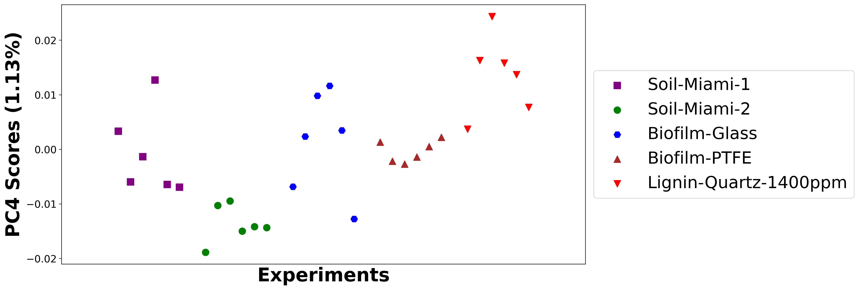

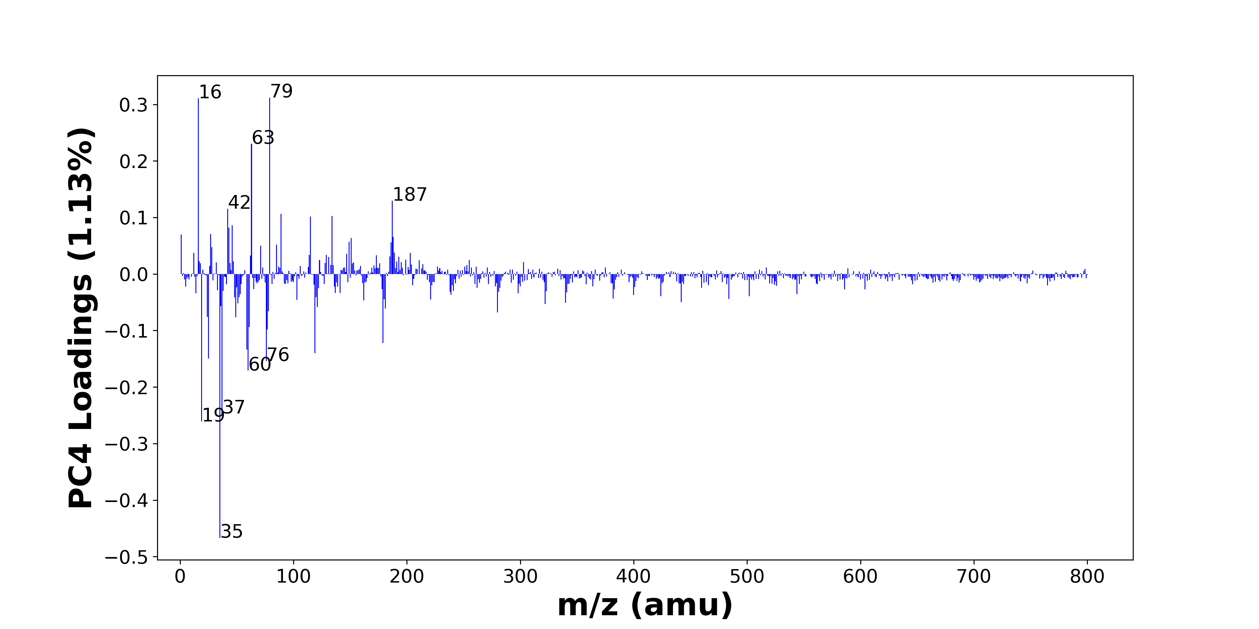

High score samples contain more:

* m/z 79 (PO3-), m/z 16 (O-), m/z 63 (PO2-), m/z 187 (), m/z 42 (CNO-), m/z 89 (), m/z 134 (), m/z 115 (), m/z 46 (NO2-), m/z 43 (BO2-, AlO-, CHNO-, C2H3O-), m/z 27 (), m/z 1 (H-), m/z 188 (), m/z 151 (), m/z 149 (), m/z 186 (), m/z 85 (), m/z 71 (C3H3O2-), m/z 28 (Si-), m/z 189 ()
* Nitrogen-containing organics, POx, NOx

Low score samples contain more:

* m/z 35 (Cl-), m/z 19 (F-), m/z 37 (37Cl-, C3H-), m/z 60 (SiO2-), m/z 76 (SiO3-), m/z 25 (C2H-), m/z 119 (NaSO4-), m/z 59 (AlO2-, C2H3O2-), m/z 179 (Si4H3O4-, SiO2NaSO4-), m/z 77 (SiO3H-), m/z 61 (SiO2H-), m/z 49 (C4H-), m/z 24 (C2-), m/z 280 (), m/z 78 (SNO2-), m/z 181 (HSi3O6-), m/z 121 (), m/z 36 (C3-), m/z 322 (), m/z 51 ()
* Hydrocarbons, SiOx, Benzene-containing organics

# Negative ion spectra, top positive loadings -- PC4

|  |  |  |  |  |  |  |  |  |
| --- | --- | --- | --- | --- | --- | --- | --- | --- |
| + Loading No. | Unit Mass | Document Mass | Initial Peak Assignment | Initial Probabilities | Measured Mass | Peak Assignment (Qualified) | Updated Peak Assignment (from Document Mass) | Updated Document Mass |
| 1 | 79 | 78.959 | PO3- | 1.0 | 78.9674 | PO3- |  |  |
| 2 | 16 | 15.9955 | O- | 1.0 | 15.9974 | O- |  |  |
| 3 | 63 | 62.9641 | PO2- | 1.0 | 62.9678 | PO2- |  |  |
| 4 | 187 |  |  |  |  |  |  |  |
| 5 | 42 | 41.9985 | CNO- | 1.0 | 42.0039 | CNO- |  |  |
| 6 | 89 |  |  |  |  |  |  |  |
| 7 | 134 |  |  |  |  |  |  |  |
| 8 | 115 |  |  |  |  |  |  |  |
| 9 | 46 | 45.9934 | NO2- | 1.0 |  |  |  |  |
| 10 | 43 | 42.9996 42.977 43.0064 43.0189 | BO2- AlO- CHNO- C2H3O- | 0.269 0.263 0.25 0.218 | 42.9985 42.9810 43.0033 43.0229 | BO2- AlO- CHNO- C2H3O- |  |  |
| 11 | 27 |  |  |  |  |  |  |  |
| 12 | 1 | 1.0084 | H- | 1.0 | 1.0085 | H- |  |  |
| 13 | 188 |  |  |  |  |  |  |  |
| 14 | 151 |  |  |  |  |  |  |  |
| 15 | 149 |  |  |  |  |  |  |  |
| 16 | 186 |  |  |  |  |  |  |  |
| 17 | 85 |  |  |  |  |  |  |  |
| 18 | 71 | 71.0139 | C3H3O2- | 1.0 | 71.0166 | C3H3O2- |  |  |
| 19 | 28 | 27.9775 | Si- | 1.0 | 27.9771 | Si- |  |  |
| 20 | 189 |  |  |  |  |  |  |  |

Note: Highlighting of the qualified peak assignments represents the error in the document masses relative to the measured mass(es) in that row. Green signifies an error < 100ppm, yellow an error from 100 to 200ppm, and red an error > 200ppm.

# Negative ion spectra, top negative loadings -- PC4

|  |  |  |  |  |  |  |  |  |
| --- | --- | --- | --- | --- | --- | --- | --- | --- |
| - Loading No. | Unit Mass | Document Mass | Initial Peak Assignment | Initial Probabilities | Measured Mass | Peak Assignment (Qualified) | Updated Peak Assignment (from Document Mass) | Updated Document Mass |
| 1 | 35 | 34.9694 | Cl- | 1.0 | 34.9695 | Cl- |  |  |
| 2 | 19 | 18.999 | F- | 1.0 | 18.9991 | F- |  |  |
| 3 | 37 | 36.9664 37.0084 | 37Cl- C3H- | 0.584 0.416 | 36.9670 37.0091 | 37Cl- C3H- |  |  |
| 4 | 60 | 59.9673 | SiO2- | 1.0 | 59.9705 | SiO2- |  |  |
| 5 | 76 | 75.9622 | SiO3- | 1.0 | 75.9663 | SiO3- |  |  |
| 6 | 25 | 25.0083 | C2H- | 1.0 | 25.0087 | C2H- |  |  |
| 7 | 119 | 118.942 | NaSO4- | 1.0 | 118.9403 | NaSO4- |  |  |
| 8 | 59 | 58.9719 59.0139 | AlO2- C2H3O2- | 0.602 0.398 | 58.9735 59.0157 | AlO2- C2H3O2- |  |  |
| 9 | 179 | 178.9114 178.9088 | Si4H3O4- SiO2NaSO4- | 0.506 0.494 | 178.9184 | Si4H3O4- SiO2NaSO4- |  |  |
| 10 | 77 | 76.9741 | SiO3H- | 1.0 | 76.9736 | SiO3H- |  |  |
| 11 | 61 | 60.9751 | SiO2H- | 1.0 | 60.9751 | SiO2H- |  |  |
| 12 | 49 | 49.0083 | C4H- | 1.0 |  |  |  |  |
| 13 | 24 | 24.0005 | C2- | 1.0 | 24.0003 | C2- |  |  |
| 14 | 280 |  |  |  |  |  |  |  |
| 15 | 78 | 77.9655 | SNO2- | 1.0 | 77.9667 | SNO2- |  |  |
| 16 | 181 | 180.9087 | HSi3O6- | 1.0 |  |  |  |  |
| 17 | 121 |  |  |  |  |  |  |  |
| 18 | 36 | 36.0005 | C3- | 1.0 |  |  |  |  |
| 19 | 322 |  |  |  |  |  |  |  |
| 20 | 51 |  |  |  |  |  |  |  |

Note: Highlighting of the qualified peak assignments represents the error in the document masses relative to the measured mass(es) in that row. Green signifies an error < 100ppm, yellow an error from 100 to 200ppm, and red an error > 200ppm.

# Negative ion spectra, molecular information from PC4 loadings plot

* The major positive PC4 loadings are m/z 79 (PO3-), m/z 16 (O-), m/z 63 (PO2-), m/z 187 (), m/z 42 (CNO-), m/z 89 (), m/z 134 (), m/z 115 (), m/z 46 (NO2-), m/z 43 (BO2-, AlO-, CHNO-, C2H3O-), m/z 27 (), m/z 1 (H-), m/z 188 (), m/z 151 (), m/z 149 (), m/z 186 (), m/z 85 (), m/z 71 (C3H3O2-), m/z 28 (Si-), m/z 189 (), indicating they are more observed in high PC4 score samples.
* The major negative PC4 loadings are m/z 35 (Cl-), m/z 19 (F-), m/z 37 (37Cl-, C3H-), m/z 60 (SiO2-), m/z 76 (SiO3-), m/z 25 (C2H-), m/z 119 (NaSO4-), m/z 59 (AlO2-, C2H3O2-), m/z 179 (Si4H3O4-, SiO2NaSO4-), m/z 77 (SiO3H-), m/z 61 (SiO2H-), m/z 49 (C4H-), m/z 24 (C2-), m/z 280 (), m/z 78 (SNO2-), m/z 181 (HSi3O6-), m/z 121 (), m/z 36 (C3-), m/z 322 (), m/z 51 (), indicating they are more observed in low PC4 score samples.
* Nitrogen-containing organics signals, such as m/z 42 (CNO-), are mostly found in positive loadings, indicating that high PC4 score samples contain more Nitrogen-containing organics.
* POx signals, such as m/z 63 (PO2-), m/z 79 (PO3-), are mostly found in positive loadings, indicating that high PC4 score samples contain more POx.
* NOx signals, such as m/z 46 (NO2-), are mostly found in positive loadings, indicating that high PC4 score samples contain more NOx.
* Hydrocarbons signals, such as m/z 24 (C2-), m/z 25 (C2H-), are mostly found in negative loadings, indicating that low PC4 score samples contain more Hydrocarbons.
* SiOx signals, such as m/z 60 (SiO2-), m/z 61 (SiO2H-), m/z 76 (SiO3-), m/z 77 (SiO3H-), are mostly found in negative loadings, indicating that low PC4 score samples contain more SiOx.
* Benzene-containing organics signals, such as m/z 49 (C4H-), m/z 36 (C3-), are mostly found in negative loadings, indicating that low PC4 score samples contain more Benzene-containing organics.

# Negative ion spectra, PCA analysis results -- PC5

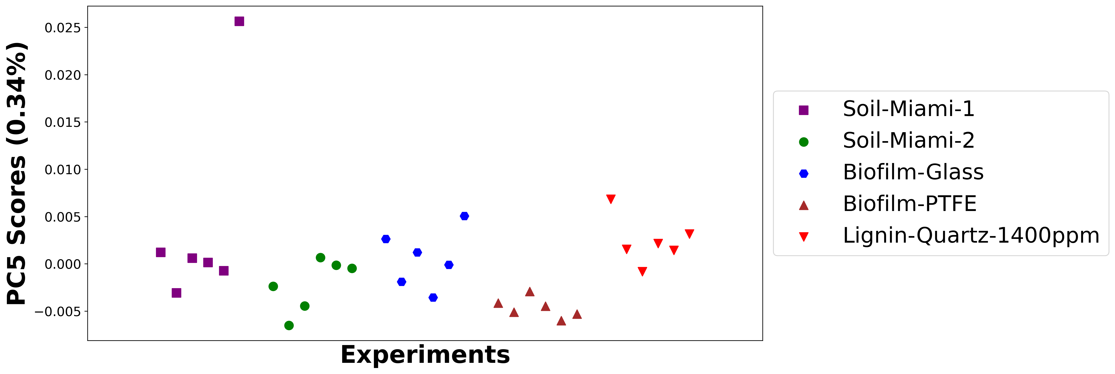

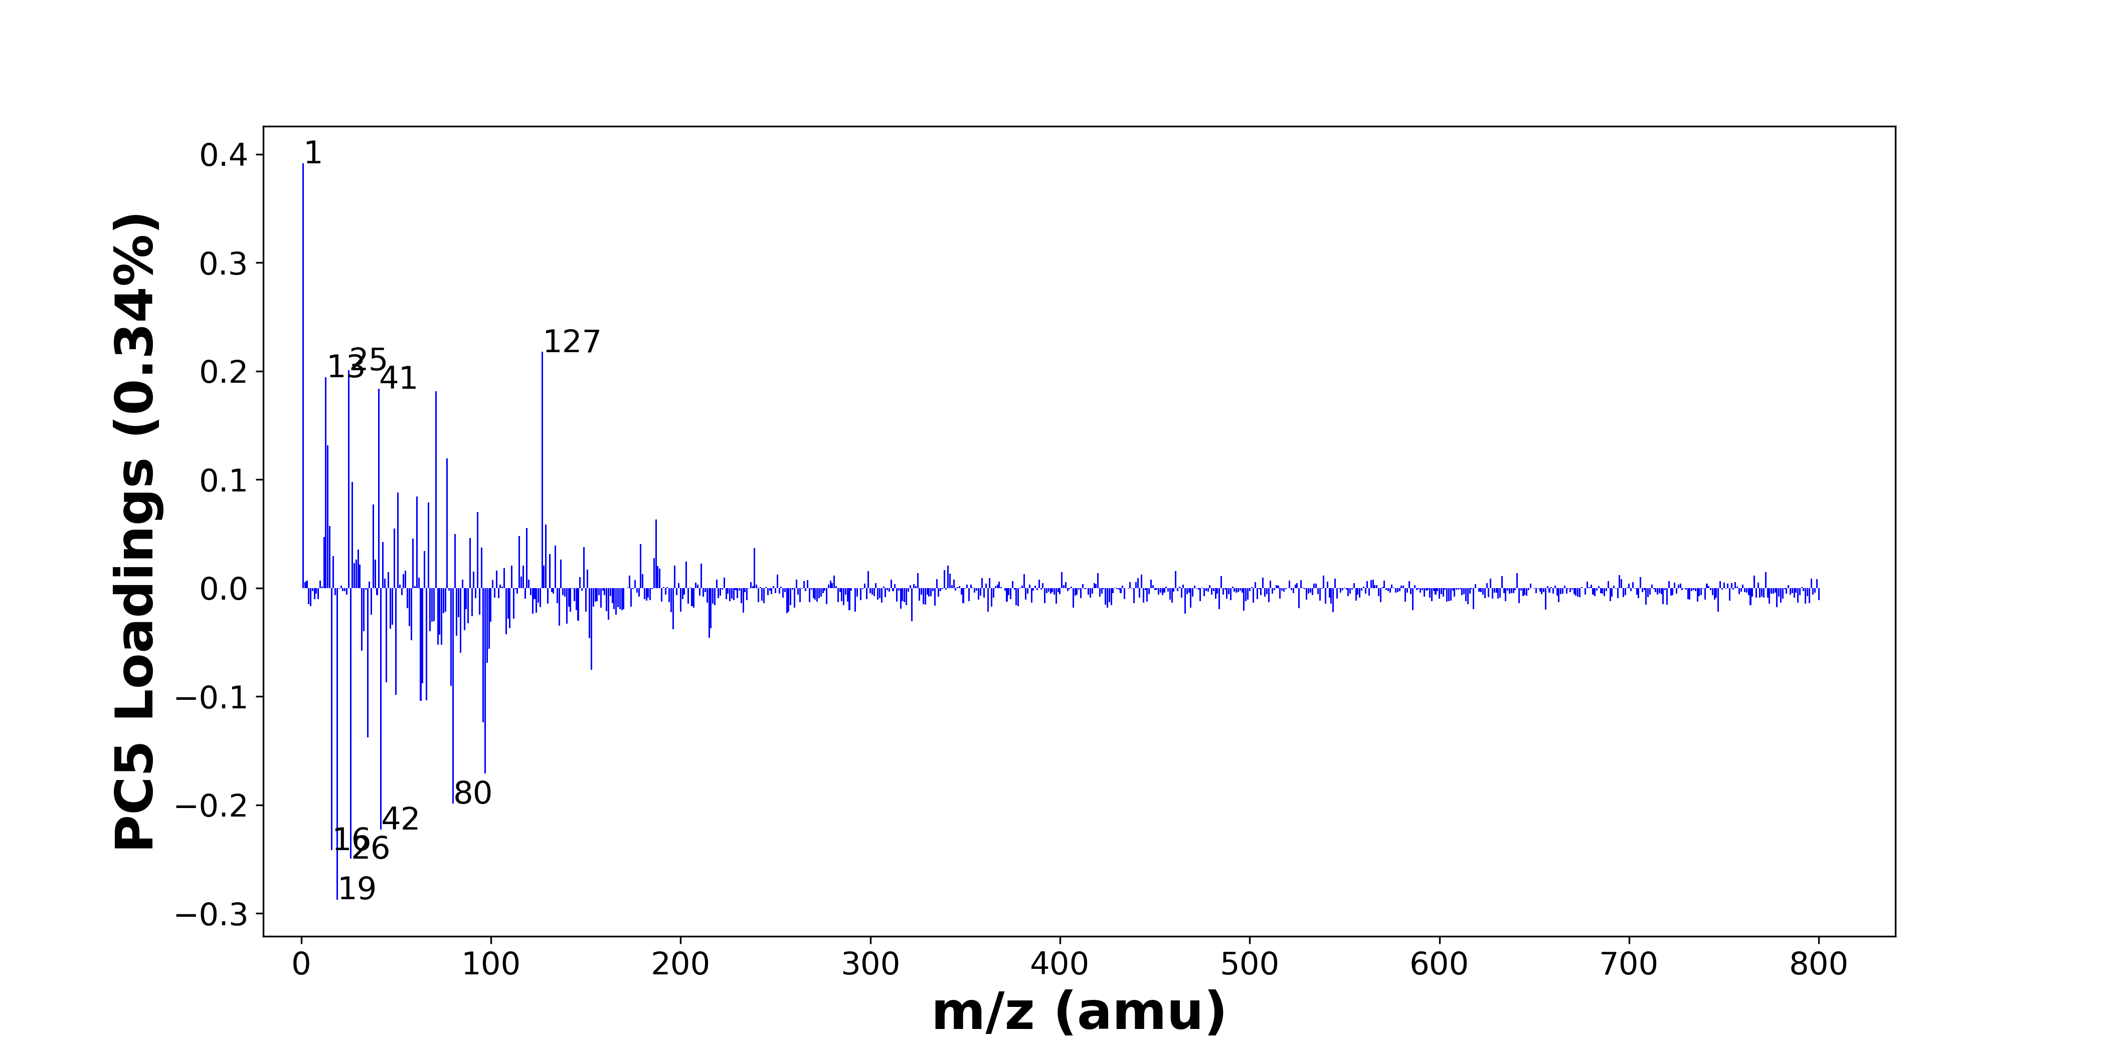

High score samples contain more:

* m/z 1 (H-), m/z 127 (), m/z 25 (C2H-), m/z 13 (CH-), m/z 41 (C2OH-), m/z 71 (C3H3O2-), m/z 14 (), m/z 77 (SiO3H-), m/z 27 (), m/z 51 (), m/z 61 (SiO2H-), m/z 67 (), m/z 38 (), m/z 93 (), m/z 187 (), m/z 129 (), m/z 15 (), m/z 119 (NaSO4-), m/z 49 (C4H-), m/z 81 ()
* Hydrocarbons, SiOx, Benzene-containing organics

Low score samples contain more:

* m/z 19 (F-), m/z 26 (CN-), m/z 16 (O-), m/z 42 (CNO-), m/z 80 (SO3-), m/z 97 (H2PO4-, HSO4-), m/z 35 (Cl-), m/z 96 (SO4-), m/z 63 (PO2-), m/z 66 (C3NO-), m/z 50 (C3N-), m/z 79 (PO3-), m/z 64 (SO2-), m/z 45 (CO2H-), m/z 153 (), m/z 98 (), m/z 84 (), m/z 32 (O2-, S-), m/z 99 (), m/z 72 ()
* Nitrogen-containing organics, SOx, POx, Organic acids

# Negative ion spectra, top positive loadings -- PC5

|  |  |  |  |  |  |  |  |  |
| --- | --- | --- | --- | --- | --- | --- | --- | --- |
| + Loading No. | Unit Mass | Document Mass | Initial Peak Assignment | Initial Probabilities | Measured Mass | Peak Assignment (Qualified) | Updated Peak Assignment (from Document Mass) | Updated Document Mass |
| 1 | 1 | 1.0084 | H- | 1.0 | 1.0085 | H- |  |  |
| 2 | 127 |  |  |  |  |  |  |  |
| 3 | 25 | 25.0083 | C2H- | 1.0 | 25.0087 | C2H- |  |  |
| 4 | 13 | 13.0084 | CH- | 1.0 | 13.0084 | CH- |  |  |
| 5 | 41 | 41.0032 | C2OH- | 1.0 | 40.9999 | C2OH- |  |  |
| 6 | 71 | 71.0139 | C3H3O2- | 1.0 | 71.0166 | C3H3O2- |  |  |
| 7 | 14 |  |  |  |  |  |  |  |
| 8 | 77 | 76.9741 | SiO3H- | 1.0 | 76.9736 | SiO3H- |  |  |
| 9 | 27 |  |  |  |  |  |  |  |
| 10 | 51 |  |  |  |  |  |  |  |
| 11 | 61 | 60.9751 | SiO2H- | 1.0 | 60.9751 | SiO2H- |  |  |
| 12 | 67 |  |  |  |  |  |  |  |
| 13 | 38 |  |  |  |  |  |  |  |
| 14 | 93 |  |  |  |  |  |  |  |
| 15 | 187 |  |  |  |  |  |  |  |
| 16 | 129 |  |  |  |  |  |  |  |
| 17 | 15 |  |  |  |  |  |  |  |
| 18 | 119 | 118.942 | NaSO4- | 1.0 | 118.9403 | NaSO4- |  |  |
| 19 | 49 | 49.0083 | C4H- | 1.0 |  |  |  |  |
| 20 | 81 |  |  |  |  |  |  |  |

Note: Highlighting of the qualified peak assignments represents the error in the document masses relative to the measured mass(es) in that row. Green signifies an error < 100ppm, yellow an error from 100 to 200ppm, and red an error > 200ppm.

# Negative ion spectra, top negative loadings -- PC5

|  |  |  |  |  |  |  |  |  |
| --- | --- | --- | --- | --- | --- | --- | --- | --- |
| - Loading No. | Unit Mass | Document Mass | Initial Peak Assignment | Initial Probabilities | Measured Mass | Peak Assignment (Qualified) | Updated Peak Assignment (from Document Mass) | Updated Document Mass |
| 1 | 19 | 18.999 | F- | 1.0 | 18.9991 | F- |  |  |
| 2 | 26 | 26.0036 | CN- | 1.0 | 26.0054 | CN- |  |  |
| 3 | 16 | 15.9955 | O- | 1.0 | 15.9974 | O- |  |  |
| 4 | 42 | 41.9985 | CNO- | 1.0 | 42.0039 | CNO- |  |  |
| 5 | 80 | 79.9573 | SO3- | 1.0 | 79.9593 | SO3- |  |  |
| 6 | 97 | 96.9696 96.9601 | H2PO4- HSO4- | 0.51 0.49 | 96.9643 | H2PO4- HSO4- |  |  |
| 7 | 35 | 34.9694 | Cl- | 1.0 | 34.9695 | Cl- |  |  |
| 8 | 96 | 95.9522 | SO4- | 1.0 |  |  |  |  |
| 9 | 63 | 62.9641 | PO2- | 1.0 | 62.9678 | PO2- |  |  |
| 10 | 66 | 65.9985 | C3NO- | 1.0 | 66.0027 | C3NO- |  |  |
| 11 | 50 | 50.0036 | C3N- | 1.0 | 50.0057 | C3N- |  |  |
| 12 | 79 | 78.959 | PO3- | 1.0 | 78.9674 | PO3- |  |  |
| 13 | 64 | 63.9624 | SO2- | 1.0 |  |  |  |  |
| 14 | 45 | 44.9982 | CO2H- | 1.0 | 44.9987 | CO2H- |  |  |
| 15 | 153 |  |  |  |  |  |  |  |
| 16 | 98 |  |  |  |  |  |  |  |
| 17 | 84 |  |  |  |  |  |  |  |
| 18 | 32 | 31.9903 31.9726 | O2- S- | 0.543 0.457 | 31.9900 | O2- S- |  |  |
| 19 | 99 |  |  |  |  |  |  |  |
| 20 | 72 |  |  |  |  |  |  |  |

Note: Highlighting of the qualified peak assignments represents the error in the document masses relative to the measured mass(es) in that row. Green signifies an error < 100ppm, yellow an error from 100 to 200ppm, and red an error > 200ppm.

# Negative ion spectra, molecular information from PC5 loadings plot

* The major positive PC5 loadings are m/z 1 (H-), m/z 127 (), m/z 25 (C2H-), m/z 13 (CH-), m/z 41 (C2OH-), m/z 71 (C3H3O2-), m/z 14 (), m/z 77 (SiO3H-), m/z 27 (), m/z 51 (), m/z 61 (SiO2H-), m/z 67 (), m/z 38 (), m/z 93 (), m/z 187 (), m/z 129 (), m/z 15 (), m/z 119 (NaSO4-), m/z 49 (C4H-), m/z 81 (), indicating they are more observed in high PC5 score samples.
* The major negative PC5 loadings are m/z 19 (F-), m/z 26 (CN-), m/z 16 (O-), m/z 42 (CNO-), m/z 80 (SO3-), m/z 97 (H2PO4-, HSO4-), m/z 35 (Cl-), m/z 96 (SO4-), m/z 63 (PO2-), m/z 66 (C3NO-), m/z 50 (C3N-), m/z 79 (PO3-), m/z 64 (SO2-), m/z 45 (CO2H-), m/z 153 (), m/z 98 (), m/z 84 (), m/z 32 (O2-, S-), m/z 99 (), m/z 72 (), indicating they are more observed in low PC5 score samples.
* Hydrocarbons signals, such as m/z 13 (CH-), m/z 25 (C2H-), are mostly found in positive loadings, indicating that high PC5 score samples contain more Hydrocarbons.
* SiOx signals, such as m/z 61 (SiO2H-), m/z 77 (SiO3H-), are mostly found in positive loadings, indicating that high PC5 score samples contain more SiOx.
* Benzene-containing organics signals, such as m/z 49 (C4H-), are mostly found in positive loadings, indicating that high PC5 score samples contain more Benzene-containing organics.
* Nitrogen-containing organics signals, such as m/z 26 (CN-), m/z 42 (CNO-), are mostly found in negative loadings, indicating that low PC5 score samples contain more Nitrogen-containing organics.
* SOx signals, such as m/z 64 (SO2-), m/z 80 (SO3-), m/z 96 (SO4-), are mostly found in negative loadings, indicating that low PC5 score samples contain more SOx.
* POx signals, such as m/z 63 (PO2-), m/z 79 (PO3-), are mostly found in negative loadings, indicating that low PC5 score samples contain more POx.
* Organic acids signals, such as m/z 45 (CO2H-), are mostly found in negative loadings, indicating that low PC5 score samples contain more Organic acids.

